MACHINE LEARNING FOR CURRICULUM ENHANCEMENT

BY

EMMANUEL SUNDAY AYODIMEJI
FTP/CSC/24/0094922

A PROJECT SUBMITTED TO
THE DEPARTMENT OF COMPUTER SCIENCE,
FACULTY OF SCIENCE, FEDERAL UNIVERSITY OYE EKITI, EKITI STATE, NIGERIA.

IN PARTIAL FULFILMENT OF THE REQUIREMENT FOR THE AWARD OF BACHELOR OF SCIENCE (B.Sc.) DEGREE IN COMPUTER SCIENCE

UNDER THE SUPERVISION OF
DR. RUFAI M. M.

AUGUST, 2025.

CERTIFICATION
This is to certify that this Project Report titled “MACHINE LEARNING FOR CURRICULUM ENHANCEMENT was carried out by EMMANUEL SUNDAY AYODIMEJI with the Matriculation Number FTP/CSC/24/0094922 in partial fulfilment for the award of Bachelor of Science Degree in Computer Science, Federal University Oye Ekiti, Ekiti State, Nigeria.

___________________________ _____________________

DR. RUFAI M. M. DATE

SUPERVISOR

___________________________ _____________________

HEAD OF DEPARTMENT DATE

DEDICATION
This work is dedicated to the Almighty God, whose wisdom, strength, and grace have been my constant guide throughout this journey.
I also dedicate this project to my beloved wife Emmanuel Sekinat Abidemi for her unwavering love, prayers, encouragement, and sacrifice, which have been my source of inspiration and determination.

ACKNOWLEDGEMENT
First and foremost, I give all glory to the Almighty God for His guidance, wisdom, and strength that sustained me throughout the course of this project.
My sincere appreciation goes to my project supervisor Dr. Rufai M. M. for his invaluable support, constructive guidance, and patience during the development of this work. His encouragement and professional insights have been instrumental in shaping the success of this research.
I also extend my gratitude to the lecturers and staff of the Department of Computer Science, Osun State Polytechnic, Iree, for providing the academic foundation and motivation that inspired this work.
Special thanks go to my colleagues and friends for their cooperation, constructive feedback, and moral support during the research and implementation stages of this project.
Finally, I am deeply grateful to my family for their unending prayers, encouragement, and sacrifices. Their belief in me has been my greatest source of strength and perseverance.

ABSTRACT
Admission processes in higher institutions often rely on cut-off marks, which can overlook important performance patterns and lead to poor course placement. This project develops a machine learning-based admission prediction system for Osun State Polytechnic, Iree, designed to enhance student placement accuracy.
The system applies a Random Forest classifier trained on student performance data (O’Level, UTME, and Post-UTME scores). To address dataset imbalance, where some courses are under-represented, the research introduces AI-generated synthetic data augmentation. This additional data helped balance the dataset, improve fairness, and strengthen prediction accuracy. Real student records were used for evaluation to ensure practical reliability.
A Python Tkinter application was implemented with features for candidate registration, data entry, prediction, and export to CSV, PDF, and Excel. The backend integrates an SQLite database, while the Random Forest model drives predictions.
Results show an accuracy of 79.5%, with notable improvement in course placement stability due to dataset balancing. The system effectively reduced admission errors, minimized human bias, and provided administrators with actionable reports.
This research demonstrates how real institutional data, enhanced with AI-synthetic records, can produce a more reliable and transparent admission framework. Future improvements will include expanding datasets across faculties, integrating cloud deployment, and applying advanced AI augmentation techniques for broader adoption.

TABLE OF CONTENT

Title Page i

Certificate ii

Dedication iii

Acknowledgement iv

Abstract v

Table of Contents vi

List of Figures ix

CHAPTER ONE

1.0 INTRODUCTION 1

1.1 General Overview 1

1.2 Statement of the Problem 2
1.3 Aim and Objectives of the Project 2

1.3.1 Aim 2

1.3.2 Objectives 2
1.4 Research Methodology 3

1.5 Significance of the Study 4

1.6 Scope of the Study 5

1.7 Limitations of the Study 6

1.8 Data Mining Review 7

CHAPTER TWO

2.0 LITERATURE REVIEW 10

2.1 Machine Leaning 10

2.1.1 Foundations and Approaches 10

2.1.2 Algorithms and Techniques 11

2.1.3 Applications of Machine Learning 11

2.2 The Database 11

2.3 Database Management System (DBMS) 12
2.3.1 Structure Query Language (SQL) 13

2.4 Data Warehouse 13

2.5 Data Mining 14
2.5.1 The scope of data mining 14
2.5.2 Data Mining Tasks 15
2.6 Other Approach of Data Mining 16
2.7 Knowledge discovery in database 17
CHAPTER THREE
3.0 METHODOLOGY 19
3.1 Data Mining Technique 19
3.2 Data Sampling 19
3.3 Business Understanding 20
3.4 Data Understanding 20
3.5 Data Preparation 21
3.6 Modeling 21
3.6.1 Descriptive Tool 22
3.6.2 Classification Model 22
3.6.3 Types Of Classification Algorithm 22

3.7 Review of Related Research 26

3.8 Summary of review of Related Research 28
CHAPTER FOUR
4.0 SYSTEM DESIGN 30
4.1 System Architecture 30

4.1.1 System Overview 30

4.1.2 Architecture Type 30

4.1.3 Components and Their Roles 30

4.2 Machine Learning Workflow 31
4.3 ER Diagram 33

4.3.1 Explanation of Relationships 34
4.4 UML Diagram 35

4.5 Interface (UI) Design 36

4.5.1 Overview 36

4.5.2 Design Principles 36

4.5.3 Layout Structure 36
CHAPTER FIVE
5.0 IMPLEMENTATION 43
5.1 Technologies Used 43
5.1.2 Programming Language 43

5.1.2 GUI Development 43

5.1.3 Database Management 43

5.1.4 Machine Learning 43

5.1.5 Data Handling 44

5.1.6 Reporting & Exporting 44

5.1.7 File Dialogs and UI Support 44

5.1.8 Model Persistence 44
5.1.9 Testing 44
5.2 Modules Description 44

5.2.1 Login Module 45

5.2.2 Admin Dashboard Module 45

5.2.3 Student Registration Module 45

5.2.4 O'Level Subject Entry Module 45

5.2.5 UTME/POST-UTME Scores Module 46

5.2.6 Prediction Module 46

5.2.7 Candidate Courses Module 46

5.2.8 Admitted Candidates Module 47

5.2.9 Machine Learning (Training and Testing) Module 47
5.3 Screenshots and Code Snippets 47
CHAPTER SIX
6.0 TESTING AND EVALUATION 50
6.1 Testing Types 50
6.1.1 Unit Testing 50
6.1.2 Integration Testing 54
6.2 Performance Evaluation 55
6.2.1 Empirical Analysis of System Performance with Large Dataset 55
6.2.2 Dataset Overview 56

6.2.3 Evaluation Criteria 57

6.2.4 Test Environment 57

6.2.5 Overall Accuracy 57

6.2.6 ML Model Performance (Classification) 58

6.3 Results and Discussion 59

6.3.1 Classification Report Interpretation 59

6.3.2 Prediction Outputs 59

6.3.3 Performance Test Results 60
6.3.4 Discussions of Results 60
6.4 Outcomes of Evaluation and Testing 61
CHAPTER SEVEN
7.0 CONCLUSION AND FUTURE WORK 63
7.1 Summary of Results 63

7.2 Project Limitations 63
7.3 Future Scope 64
REFERENCES 65
APPENDIX: PROGRAM CODE 68

LIST OF FIGURES
Fig 4.1 Machine Learning workflow 32
Fig 4.2 ER Diagram 33
Fig 4.3 UML Diagram 35
Fig 4.4 Login Screen 36
Fig 4.5 Admin Dashboard 37
Fig 4.6 Bio-data Registration page 38
Fig 4.7 O’level Portal 38
Fig 4.8 UTME/postUTME portal 39
Fig 4.9 Registered Candidates Portal 39
Fig 4.10 Student Prediction Portal 40
Fig 4.11 Candidate’s Course Portal 41
Fig 4.12 Admitted Candidate’s Portal 42
Fig 5.1 login screen module code snippet 47
Fig 5.2 student registration module code snippet 48
Fig 5.3 prediction module code snippet 48
Fig 5.4 training and testing module code snippet 49
Fig 6.0 Snapshot of Dataset after preprocessing 56

CHAPTER ONE

1.0 INTRODUCTION

1.1 General Overview
In recent years, the advancement of database technologies has led to the accumulation of vast volumes of data across various domains, including education. However, raw data alone is not inherently useful until it is processed and analyzed to extract meaningful insights. This is where data mining plays a critical role, enabling institutions to uncover hidden patterns and relationships within datasets to support better decision-making.
In the educational sector, leveraging data mining allows institutions to assess and evaluate student performance more effectively. By applying modern statistical and computational methods, schools can identify areas for curriculum improvement and develop targeted interventions to enhance learning outcomes. Data mining can transform traditional reporting into intelligent systems capable of predicting academic performance and supporting strategic planning.
Historically, before the development of database technologies (prior to the 1960s), data analysis relied heavily on manual file processing systems that were time-consuming and often ineffective. Over time, data mining evolved through the following stages:
- Data Collection and Creation
- Data Management (including warehousing and pre-processing)
- Data Analysis and Interpretation
This evolution has led to what is now known as Knowledge Discovery in Databases (KDD), a comprehensive process that includes data management, analysis, and predictive modelling. KDD empowers institutions to move beyond intuition-driven decisions and instead rely on data-driven insights to improve academic performance and resource planning.

1.2 Statement of the Problem
Manually analyzing large volumes of student data is both time-consuming and inefficient. As educational institutions generate increasing amounts of data, there is a pressing need for intelligent systems capable of automatically analyzing, interpreting, and correlating this data to inform curriculum development and policy-making.
The field of Knowledge Discovery in Databases (KDD) emerged to address this challenge. As defined by Fayyad et al. (1996), KDD is a multi-stage, iterative process designed to extract valid, understandable, and useful patterns from large datasets. However, many institutions still rely on outdated decision-making practices that fail to leverage the insights buried within their databases.
This research aims to develop an intelligent system that predicts student’s most suitable course of study in higher education based on historical academic data. Such a system can support more personalized admissions decisions and ultimately improve student outcomes.
One key challenge is imbalanced student records, and this research addresses it by introducing AI-generated synthetic data to enrich under-represented categories.
1.3 Aim and Objectives of the Project

1.3.1 Aim

The aim of this project is to design and implement a machine learning–based admission prediction system that accurately predicts students’ eligibility and suitable courses based on O’Level results, UTME, and Post-UTME scores, thereby improving decision-making in the admission process.

1.3.2 Objectives
- To develop a structured database that stores candidate’s biodata, O’Level grades, and UTME/Post-UTME scores in an integrated system.
- To apply machine learning techniques (Random Forest and rule-based logic) for predicting students’ admission eligibility and suggesting suitable courses.
- To design a user-friendly interface for administrators to view, manage, and analyze admission records effectively.

1.4 Justification

1. Problem and need
Higher education institutions face rising application volumes, diverse applicant backgrounds, and limited staff/time to make consistent, evidence-based admission and curriculum decisions. Traditional manual review of biodata, O’Level results, UTME and post-UTME scores is slow, error-prone and often opaque. At the same time, curriculum and placement decisions that don’t use data risk poor student-course fit, increased dropout rates, and inefficient use of scarce teaching and lab resources. There is therefore a clear need for a data-driven system that helps predict appropriate course placements for improved learning outcomes.

2. Direct benefits (educational & administrative)
- Improved decision quality: A predictive model (Random Forest) uses historical patterns in O’Level grades, UTME/post-UTME scores and biodata to make consistent, evidence-based course placement suggestions.
- Early intervention: The system can flag at-risk students before they begin classes, enabling targeted remedial support (tutoring, bridging courses).
- Resource optimization: Admissions and timetabling decisions can be better aligned with student strengths, reducing wasted seats and mismatched placements in costly lab/field courses.
- Transparency & fairness: Combining rule-based minimum requirements with ML predictions reduces ad-hoc human bias while keeping institutional constraints explicit.
- Actionable curriculum insights: Feature-importance outputs reveal which subjects/skills most influence success in particular science programmes (e.g., Mathematics, Physics, English). These insights can guide curriculum review and pre-admission remedial offerings.

3. Research and institutional significance
- This project demonstrates a practical hybrid approach (rule-based + ML) for admissions and curriculum enhancement, a gap identified in some prior studies.
- It contributes empirical evidence about which student indicators best predict success in Faculty of Science programmes (Computer Science, Physics, Industrial Chemistry, Microbiology, Animal & Environmental Biology, Biochemistry, Plant Science & Biotechnology, Applied Physics, Mathematics & Statistics).
- The system can serve as a replicable prototype for other faculties or institutions, and the dataset plus the trained model enable future academic studies (feature interactions, fairness audits, model comparison).

4. Technical justification of choices
- Random Forest (RF): RF balances accuracy with robustness. It handles nonlinear relationships, works well with mixed data types, tolerates noisy/missing inputs, supports multi-class outputs (predicting multiple courses), and supplies feature importance scores for interpretability — all critical for admission/course-prediction tasks.
- Python ecosystem: pandas, numpy, scikit-learn offer efficient development and reproducible model training. Python is widely used in academia and production prototyping.
- SQLite for backend: Lightweight, serverless, easy to deploy with the Tkinter GUI; suitable for the prototype and campus deployments where heavy DB infrastructure isn’t needed initially.
- Tkinter GUI: Rapid desktop GUI prototyping allows administrators to register students, view records, run predictions, and manage data without web deployment complexity — useful for proof-of-concept and local admin environments.
- Modular architecture: Database ↔ Preprocessing ↔ Model ↔ GUI makes the system maintainable and allows future swaps (e.g., to a web front-end, PostgreSQL, or a different ML model).

5. Expected measurable outcomes and evaluation
The project provides quantitative evaluation that demonstrates value:
- Model metrics: accuracy, precision, recall, F1-score and confusion matrix using k-fold cross-validation (e.g., 5 or 10 folds) to produce stable estimates.
- Operational metrics: reduction in average processing time per application, proportion of correct course placements (validated against historical outcomes), number of at-risk students identified earlier.
- Interpretability: ranking of features (UTME, Post-UTME, key O’Level subjects) that shape curriculum decisions.

1.5 Research Methodology
The methodology for this research includes:
- Analyzing existing data mining techniques and identifying those most applicable to educational data.
- Consulting with database developers and educational technologists for system design input.
- Conducting a literature review and gathering data from online academic resources.
- Implementing and testing machine learning models using student admission data. This involved training models like Random Forest on historical data, applying k-fold cross-validation, and evaluating performance with metrics such as accuracy and confusion matrix.
- Synthetic data was generated using AI tools (e.g., Faker, random sampling) to balance minority classes and improve robustness.

1.5 Significance of the Study
This study is significant in several key areas:
- Improved Student Placement Accuracy: By leveraging machine learning and structured academic data, the system enhances the accuracy of course placement decisions. This reduces the mismatch between student abilities and course demands, increasing the likelihood of academic success.
- Data-Driven Admission Decisions: Traditional admission systems often rely solely on cut-off marks without a comprehensive analysis of candidate performance. This study introduces a data-driven framework that considers multiple academic indicators (O’Level, UTME, and Post-UTME scores) to support informed decision-making.
- Reduction of Admission Errors: The system helps minimize human errors, biases, and inconsistencies in student placement by automating the prediction process using trained classification models and clearly defined admission rules.
- Support for Institutional Planning: Educational institutions can use insights from this system to better plan for program capacities, identify high-demand courses, and adjust admission strategies based on student performance patterns.
- Demonstration of Artificial Intelligence in Education: This project showcases a practical application of artificial intelligence (specifically, machine learning) in the Nigerian educational system, providing a blueprint for further innovations in curriculum development and student advising.
- Enhanced User Experience Through Automation: With an intuitive user interface, the software simplifies student data entry, prediction, and reporting processes, making it easier for admission officers to work efficiently and with fewer resources.
- Balanced Dataset for Better Accuracy: By supplementing institutional data with AI-generated synthetic records, the system reduces bias from data imbalance and improves generalization of predictions.

1.6 Scope of the Study
This study focuses on the design and implementation of a machine learning-powered admission prediction system tailored to Osun State Polytechnic, Iree (Faculty of Science). The dataset is drawn from real institutional records, augmented with AI-generated synthetic data to balance class distributions. The scope includes developing a structured database, training Random Forest models with cross-validation, deploying a Tkinter-based GUI, and focusing predictions on selected science courses: Computer Science, Physics, Industrial Chemistry, Microbiology, Biochemistry, Animal & Environmental Biology, Applied Physics, Plant Science & Biotechnology, and Mathematics & Statistics.
The scope includes the following:
- Development of a structured student database to store biodata, academic records, and prediction outcomes.
- Implementation of a Random Forest classifier to predict courses based on historical patterns.
- Integration of a rule-based admission engine alongside the machine learning model to reflect institution admission requirements and policies.
- Design of a user-friendly desktop application using Python’s Tkinter library to manage student records and visualize predictions.
- Focus on selected science courses, including: Computer Science, Physics, Industrial Chemistry, Microbiology, Biochemistry, Animal and Environmental Biology, Applied Physics, Plant Science and Biotechnology, and Mathematics and Statistics.
The system is intended for use within higher institutions in Nigeria, specifically in the context of Faculty of Science admissions. Broader implementation across other faculties or institutions may require further adaptation and expansion of the dataset and model.

1.7 Limitations of the Study
Despite its usefulness and innovative approach, the study has several limitations:
- Restricted Dataset: The model was trained and tested using a limited and possibly synthetic dataset. This may not capture the full diversity of student performance patterns across various institutions or academic years, affecting generalizability.
- Synthetic or Simulated Dataset: The machine learning model was trained on a synthetic or dummy dataset, rather than real student data due to privacy, accessibility, or ethical concerns. This limits the model’s ability to fully generalize to real-world admission scenarios and may affect prediction accuracy in live deployments.
- Faculty-Specific Focus: The system is designed exclusively for the Faculty of Science. It does not accommodate admission requirements or prediction rules for other faculties such as Engineering, Arts, or Social Sciences.
- Static Admission Requirements: The rule-based engine uses hardcoded admission requirements. Any future changes in institutional or departmental cut-off marks or subject requirements would require manual updates to the system.
- Local Deployment Only: The application is designed as a desktop-based system using Tkinter. It does not support multi-user access, remote login, or web-based deployment, which limits scalability and institutional adoption across departments or campuses.
- No Real-Time Feedback or Advising: The system provides predictions but lacks interactive advising features, such as recommending ways to improve eligibility for preferred courses.
- Although AI-generated data helps balance the dataset, it may not perfectly capture the complexity of real-world student performance, possibly introducing synthetic bias.
- Dataset is institution-specific (Osun State Polytechnic, Iree) and results may not generalize to other schools without retraining.
- Focus is limited to Faculty of Science; extension to other faculties would require further dataset expansion.
- The system is still desktop-based (Tkinter + SQLite) and lacks cloud-based or multi-user accessibility.

1.8 Data Mining Review
Data mining refers to the process of discovering hidden patterns and trends within large datasets. As data volumes continue to grow, doubling approximately every three years. The role of data mining becomes increasingly critical in transforming raw data into actionable knowledge.
However, the effectiveness of data mining depends on the quality and representativeness of the data. Poorly sampled datasets may yield misleading results. Additionally, the over-reliance on data mining without a clear understanding of its limitations may lead to unrealistic expectations.
Thus, while data mining is a powerful tool, its results should be interpreted carefully and applied thoughtfully especially in complex domains such as education.
Commonly used methods of educational data mining include:
1. Classification: This is used to predict categorical outcomes, such as pass/fail, admitted/not admitted, or course placement. It involves mapping input variables (e.g., UTME score, subject grades) to predefined categories.
Common algorithms:
- Decision Trees
- Random Forest
- Support Vector Machines (SVM)
- Naïve Bayes
- K-Nearest Neighbors (KNN)
2. Clustering: Clustering is an unsupervised learning technique used to group students with similar characteristics without predefined labels. This helps identify learning patterns or categorize students into performance groups.
- K-Means
- Hierarchical Clustering
- DBSCAN
3. Regression: It predicts continuous numeric outcomes, such as expected exam scores or GPA. It helps understand how academic variables impact performance.
Common algorithms:
- Linear Regression
- Ridge/Lasso Regression
- Polynomial Regression
4. Association rule mining: This method discovers interesting relationships or patterns among variables in large datasets — typically used for identifying co-occurring behaviours.
Common algorithms:
- Apriori
- FP-Growth
5. Recommendation systems: They are used to provide personalized academic suggestions (e.g., recommending courses or study materials) based on student profiles or historical behavior.
Common techniques:
- Collaborative Filtering
- Content-Based Filtering
- Matrix Factorization
6. Sequencial pattern mining: This uncovers patterns in the sequence of events, such as a student’s progression through courses or learning modules. And a typical application example is analyzing how course sequences impact overall academic performance.

CHAPTER TWO

2.0 LITERATURE REVIEW

2.1 Machine Leaning
Machine Learning (ML) is a subfield of artificial intelligence (AI) that focuses on developing algorithms and statistical models that enable computers to learn patterns and make predictions or decisions without explicit programming. The concept originated from the broader vision of AI in the mid-20th century, with early foundations laid by researchers like Alan Turing, Arthur Samuel, and Frank Rosenblatt. Over the decades, ML has evolved from basic pattern recognition to sophisticated systems capable of handling large-scale, high-dimensional, and heterogeneous datasets (Jordan & Mitchell, 2015).

2.1.1 Foundations and Approaches
Machine learning methods are broadly categorized into three main types: supervised learning, unsupervised learning, and reinforcement learning.
1. Supervised learning involves training models on labeled data, where input-output pairs guide the algorithm to learn mappings. This approach is widely applied in classification and regression tasks, including medical diagnosis, spam filtering, and stock price prediction (Bishop, 2006).
2. Unsupervised learning deals with unlabeled datasets, focusing on identifying hidden patterns or groupings within the data. Techniques such as clustering and dimensionality reduction are key here, often applied in customer segmentation and anomaly detection (Hastie, Tibshirani & Friedman, 2009).
3. Reinforcement learning enables agents to learn by interacting with an environment, receiving feedback in the form of rewards or penalties. Applications include robotics, autonomous vehicles, and game-playing AI systems such as AlphaGo.

2.1.2 Algorithms and Techniques
Over time, numerous algorithms have emerged to address different problem domains. Linear regression, decision trees, and support vector machines represent classical methods, whereas more recent advances include ensemble learning techniques like Random Forests and Gradient Boosting Machines, which combine multiple learners to improve prediction accuracy and robustness (Breiman, 2001). In the last decade, deep learning driven by artificial neural networks has gained prominence, enabling breakthroughs in speech recognition, image classification, and natural language processing.
Random Forests, for example, have become particularly popular for structured/tabular data due to their high accuracy, ability to handle missing values, and resistance to overfitting. These qualities make them suitable for real-world decision-support systems, including admission prediction, fraud detection, and healthcare analytics.

2.1.3 Applications of Machine Learning
Machine learning has permeated diverse domains. In healthcare, ML models assist in early disease detection, personalized treatment, and drug discovery. In finance, they power credit scoring, algorithmic trading, and risk assessment. In manufacturing, predictive maintenance models anticipate equipment failures, while quality control systems detect defects in production lines. Additionally, in education, ML is applied in personalized learning systems, admission prediction, and student performance analytics (Zhang & Cui, 2020).

2.2 The Database
A database is a structured collection of interrelated data that is stored across one or more computer systems, designed to support the operations of an organization efficiently (Shapiro, 1996). It was developed to address the limitations of the traditional file system approach, such as redundancy, inconsistency, and inefficiency in data access and processing.
Databases can be broadly categorized into different types based on structure and usage:
- Transactional Databases: These store records of transactions, such as items purchased in a store, each with a unique transaction ID.
- Object-Oriented Databases: Based on object-oriented programming, these treat entities as objects, allowing for complex data modeling.
- Object-Relational Databases: These extend relational databases by supporting complex data types and object-oriented features.
- Spatial Databases: These store spatial data like maps, satellite images, and geographic information systems (GIS).

2.3 Database Management System (DBMS)
A Database Management System (DBMS) is a software suite that allows users to store, modify, and retrieve data efficiently. It provides tools to manage databases, ensuring data consistency, integrity, and accessibility. Examples include MySQL, Oracle, and Microsoft Access.
DBMS applications are widespread, including:
- Library management systems
- Automated teller machines (ATMs)
- Flight reservation systems
- Inventory management systems
DBMSs are classified by the way they structure data internally: relational, network, flat-file, or hierarchical. A standard language used for interacting with databases is Structured Query Language (SQL), which simplifies data manipulation through queries such as:
SELECT * FROM Students WHERE Name = "Smith" AND Age = 35;
The information from a database can be presented in a variety of formats. Most DBMSs include a report writer program that enables you to output data in the form of a report. Many DBMSs also include a graphic component that enables you to output information in the form of graph and chart.
2.3.1 Structure Query Language (SQL)
In order to effectively retrieve, update, delete or manipulate the database, a generated language which is structure Query language (SQL) is used. This language is easy to use because many database applications are design to handle Queries. The development of the structure Query language has ease programmers and database developing endless code to manipulate simple data in the structure.

2.4 Data Warehouse
Due to the fast growing tremendous amount of data collected and stored in large and numerous database which has far exceeded our human ability for comprehension without a powerful tool, a technology which provides a great boost to the database and information industry and make a huge number database and information respiratory available for transaction management, information retrieve and data analysis emerged. This technology is called dataware house. Data warehouse technology include data cleansing, data integration and on-line analytical processing (OLAP), that is, analysis techniques with functionality such as summarization, consolidation and aggregation as the ability to view information from different angles.
A data warehouse is a relation database management system (DBMSs) designed specifically to meet the needs of transaction processing system. It is any centralized data repository which can be queried for business benefit and provides data that is already transformed and summarized (Start Soft 2005)
Some features of a data ware house are:
- It is respiratory for information and record result
- Improves access to integrated data
- Ensure integrity and quality
- provides an historical perspective
- It is used for a variety of purpose
Data ware house collect information about subject than span an entire organization and thus its scope is enterprises, while data mart is a department subset of a data ware house, it focuses on selected subject and thus its scope is department wide. Although data ware house technology which consists of the OLAP tools support multidimensional analysis and decision making, addition data analysis such as data analysis classification, clustering and the characterization of data changes over time. This data analysis of data changes over time. This data analysis tool is called data mining tool which perform strategies, knowledge, scientific and medical research.

2.5 Data Mining
Data mining simply refers to extracting or “mining” knowledge from large amount of data. It is the process of discovering interesting knowledge from large amount of data stored either in databases, dataware house, or other information repositories.
Data mining also refer to using variety of technique to identify nuggets of information or decision making knowledge in bodies of data, and extracting these in such a decision support, prediction, forecasting and estimation. By performing data mining, interesting knowledge, regularities or higher-level information can be extracted from database and viewed or browse different angles. The discovering knowledge can be applied to decision making, process control, information management and data analysis system that cannot handle large amount of data.
2.5.1 The scope of data mining
Data mining derive it name from the similarities between the searching for valuable business information in a larger database for example, finding linked product in gigabytes of stored data and mining a mountain for a vein of valuable one. Both processes required either sifting through an immense amount of material, or intelligently probing it to find exactly where the values reside.
- Automated prediction trend and behaviour. Data mining automated is the process of finding predictive information in a large database. A typical example of a predictive problem is targeted marketing. Other predictive problem includes forecasting, bankruptcy and other form of default and identifying segment of a population likely to respond similarly to given event.
- Automated discovering previous unknown patterns. Data mining tool sweep through database and identify previously hidden pattern in one step. An example of pattern discovery is the analysis of retail scale data to identify seemingly unrelated product that are often purchase together other pattern problem includes detecting anomalous that could represent data entry keying errors.
2.5.2 Data Mining Tasks
The objective of data mining is to identify valid novel, potentially useful, and understandable corrections and pattern in existing data. The task of data mining can be modeled as either predictive or descriptive in nature.
A predictive model makes a predictive about value of data using know result found from different data WHILE the descriptive model identifies patterns or relationship in data. Unlike the predictive model, a descriptive model server as a way to explore the properties of the data examined, not to predict new properties predictive model data mining tasks include classification, prediction, regression and time series analysis. The descriptive task encompasses method such as clustering summarization, association rules and sequence analysis.

DATA MINING
PREDICTIVE
DESCRIPTIVE
Classification, Prediction, Regression, Time Series Analysis
Clustering, Summarization, Association rules, Sequence Analysis

2.6 Other Approach of Data Mining
Data mining approaches can yield the benefit of automation on existing software and hardware plant form and can be implemented on new system as existing plant form are upgraded and new product developed. When data mining is implemented on high performance parallel processing systems, they can analyze with more model to understand complex data. The most commonly used approaches of data mining are:
- Artificial Neutral Network: Non- linear predictive model that learn though training and resemble biological natural network in structure.
- Decision Trees: Tree shape structure that represent set of decisions. These decisions guarantee rules for the classification of dataset. Specific decision tree method include classification and regression tree (CART) and chi-square Automatic interaction detection(CHAID)
- Rules Induction: In the extraction of useful if then rules from data based on statistical significant
- K-Means Clustering: In mapping the k-means algorithm to FPGA(Field Programmable Gate Array) hardware we examined algorithm level transforms that dramatically increased the achievable parallelism. It is a common solution to the segmentation of multidimensional data. It is an iterative algorithm that assigns to each pixel a label indicating which of K cluster the pixel belong to the software implementation of K-means user floating-point arithmetical and Euclidean distances.
2.7 Knowledge discovery in database
Knowledge discovery in database in database is the finding of understanding knowledge in every large set of real word database. The steps in the process of knowledge discovery in database are as follow:
- Data Selection: this is the process of selecting or segmenting the data relevant to the analysis task is done from the database.
- Data Cleaning: this is the removal of noise and inconsistent data since data are usually contaminated by error in either the value of attributes or class. Data cleansing is done by reconfiguring the data to ensure a consistent format because data is draw from several sources
- Data Integration: this is a situation when multiple data sources may be combined. This can be done together with data cleansing as a preprocessing step where the resulting data are stored in a data warehouse
- Data Transformation: this is where the data transformed or consolidated into forms appropriate for mining by performing summary or aggregate operation.
- Data Mining: this is an essential process where intelligent methods are applied in order to extract data patterns.
- Pattern Evaluation: This is to identify the truly interesting patterns knowledge based on some interestingness measures, interestingness measures are function used to guide the mining process or after discovering to evaluate the discovery patterns.
- Knowledge Presentation And Visualization: this is a process where visualization and knowledge presentation techniques are used to present the mined knowledge to the user
- The Pattern Identify by the system are interpreted into knowledge which can be use to support human decision making

CHAPTER THREE
3.0 METHODOLOGY
3.1 Data Mining Technique
There are various constraints that are consider in predicting student course of study from the types, there are two fundamental constraints that govern the prediction of student course of study. These are that all students must pass their UTME science subjects. There are many criteria used to ascertain the quality of data mining. Most common is that a student is not expected to go for a course that they does whether a data mining technique in predicting student course of study is good or not i.e. if it is usable by the faculty of science .
3.2 Data Sampling
The CRIPS-DM methodology suggested by Chapman etal .(2000) involve six phases, namely business understanding, data understanding, data preparation, modeling, evaluation and development
In this study, as the possible areas of test depend on the data available, and the detailed business objective cannot be identified until the data was studied. Consequently, this phase has to be performed in parallel with the data understanding and data preparation phase.
The initial phase of data understanding focuses understanding the objectives and requirement from the student registrar office the data understanding phase start with an initial data collection and proceeds with action in order to get familiar with the data.

BUSINESS UNDERSTANDING
DATA UNDERSTANDING
DATA PREPARATION
MODELING
EVALUATION

3.3 Business Understanding
The first phase of CRIPS-DM is business understanding which focuses on project objectives and requirement from academic perspective, and converting this knowledge into a data mining problem definition as well as designing a preliminary plan to achieve the objectives to identify the research gap and the potential problems, literature study was carried out and relevant work as been identified. In the study, research relevant to education data and predicting student course of study were sought and suitable mining algorithm for predictive purpose were also selected
3.4 Data Understanding
The second phase is data understanding which begins with initial data collection. At this point, the data collection from the students needs to be and understood. In order to be familiar with data, the next step in data understand is to identify data quality problem, get some insight about the data and detect interesting subsets to form hypothesis so as to uncover the hidden information within the data collected, as a result of preprocessing phase the data quality problem will be identified

3.5 Data Preparation
Data preparation concern all activities needed to construct the final dataset for modeling purpose. The tasks are most likely to be carried out multiple times and may not be in any prescribe manner. Different datasets tend to expose new issues and challenges. With the goal in mind, it is important to choose the right data mining algorithms, techniques and tools which are expected to give best result with the provided data. Dependencies among different subsets of attributes are expected to be exhibited by different subsets of data. Most often, not all variable are used in analyzing and modeling process. This phase needs to be conducted repetitively for determining suitable attributes to be used as predictors and target (output).
To get full insight of data distribution and in identifying out liar, predictive analysis was conducted for exploratory purpose. In this study qualification upon entry and entry and examination results were consider as predictor variables.
3.6 Modeling
During the modeling phase, modeling techniques were selected and applied to the dataset used in the study. This phase include selecting an appropriate modeling technique, building the model and followed by assessment of model.
Subsequently, the model selection involves selecting appropriate technique for the problem, refine the models whenever is necessary in order to meet the requirement and other constraints. After reviewing data mining technique, the descriptive approaches employed in the study were identified, namely the classification method. Since the aim of the experiment was to study the pattern and getting some information within the enrollment data, no specific target has been identified. To this end, cluster were generated by classification method, and later used as target or output for predictive approach. As a result, the predictive method will be able to predict in which cluster the future student will falls into based on the enrollment information.

3.6.1 Descriptive Tool
Initially, descriptive statistics was carried out to investigation the nature of the database and the distribution of each attribute. Frequency tables were generated and the correlation analysis was also conducted to determine the relationship among the attributes, including cross tabulation analysis displays relationship between two or more categorical (nominal or ordinal) variable
3.6.2 Classification Model
Among the predictive models, classification is probably the best understand of all data mining approaches. The common characteristic of classification tasks are;
- Learning is supervised
- The dependent variable is categorical
- The model built of a table to assignment data to one of a set of well define classes.
The goal of classification is to build asset of the model that can correctly predict the class of different objects. The input of these method is a set of object[ i.e. training data], the classes which these objects belong to and a set of variable describing different characteristics of the object (i.e. independent variable) once such a predictive model is built, it can be used to predict the class of objects for which classification is known as prior.
The key advantages of supervised leaning method over unsupervised learning method by having an explicit knowledge of the classes, the different object belong to these algorithms can perform an effective feature selection if that lead to better prediction accuracy.
3.6.3 Types Of Classification Algorithm

Decision Trees

A Decision Tree is a tree-structured model where each internal node represents a test on an attribute (e.g., UTME score), each branch represents an outcome of the test, and each leaf node represents a class label (e.g., “Admitted” or “Not Admitted”).
Decision Trees are constructed by recursively splitting the dataset into subsets based on the most significant feature at each level using measures like Gini Index or Information Gain.
Core advantages
- Easy to interpret and visualize.
- Handles both numerical and categorical data.
- Requires minimal data preprocessing.
Limitations:
- Prone to overfitting, especially with noisy data.
- Can be unstable — small data changes may lead to different tree structures.

Random Forest
Random Forest is a powerful ensemble learning algorithm that builds upon the decision tree method to improve prediction accuracy, stability, and generalization capability. It belongs to the family of bagging (Bootstrap Aggregating) techniques and was introduced by Leo Breiman in 2001. Unlike a single decision tree, which may be prone to overfitting. Random Forest creates a large number of decision trees and combines their predictions to produce a final output.
In classification problems, such as predicting the course to which a student is most likely to be admitted based on academic performance, the Random Forest outputs the class with the majority vote among the individual trees. For regression problems, it returns the average prediction of the trees.
In the context of this student admission prediction system, Random Forest is particularly useful because:
- It can handle mixed data types (numerical UTME scores, categorical O’Level grades).
- It is resistant to noisy or incomplete student records.
- It can rank features such as English or Mathematics grades by importance, helping explain predictions.

Theoretical Foundation
The Random Forest algorithm is based on two core ideas:
a. Bagging (Bootstrap Aggregating): This technique involves training each decision tree on a random subset of the dataset generated through sampling with replacement. This reduces variance and prevents the model from memorizing the training data.
b. Random Feature Selection: When building each tree, the algorithm randomly selects a subset of features at each split rather than considering all features. This adds decorrelation between trees, ensuring that not all trees make the same errors.
These two mechanisms together make Random Forest robust and capable of capturing complex patterns without overfitting.

Working Mechanism
The step-by-step process for building a Random Forest is:
- Bootstrap Sampling: From the training dataset of size N, create multiple subsets by random sampling with replacement. Each subset is used to train one decision tree.
- Tree Construction: At each node in a tree, choose a random subset of features (of size mtry) to consider for splitting, rather than all features.
- Tree Growth: Trees are grown to their maximum depth without pruning. This ensures that each tree has high variance individually.
- Voting/Averaging: For classification, each tree predicts a class label, and the final output is determined by majority voting. For regression, each tree predicts a value, and the final output is the mean of predictions.
- Out-of-Bag (OOB) Error Estimation: Since each tree is trained on a bootstrap sample, about one-third of the data is left out. These unseen samples are used to estimate the OOB error, which serves as a built-in validation accuracy.
Core Advantages:
- High Prediction Accuracy: Performs well on complex datasets.
- Handles High Dimensionality: Works even when the number of features is large compared to the number of samples.
- Robust to Missing Data: Can maintain accuracy even if some features are missing.
- Resistant to Overfitting: Due to averaging of many trees.
- Feature Importance Ranking: Identifies which academic factors most influence predictions.
- Built-in Cross-Validation: OOB error estimation allows internal model validation.
Limitations:
- Lower Interpretability: Compared to a single decision tree, understanding the overall decision process is harder.
- Computational Cost: Training hundreds or thousands of trees can be time-consuming, especially with large datasets.
- Memory Usage: Large forests can consume significant memory.
- Slower Predictions: Compared to simpler models like logistic regression, especially in real-time applications.

Relevance to This Project
In the student admission prediction system, Random Forest was chosen due to its ability to:
- Capture Nonlinear Relationships: Many academic features, such as combinations of O’Level subject grades and UTME scores, interact in complex ways that cannot be captured by linear models.
- Handle Noisy Data: Student datasets often contain inconsistencies, missing fields, or recording errors; Random Forest is resilient in such cases.
- Support Multi-class Classification: This system predicts multiple science courses (e.g., Computer Science, Biochemistry, Microbiology), not just binary outcomes.
- Rank Academic Indicators: Helps in understanding which subjects most influence admission decisions, aiding transparency in the selection process.
- Blend with Rule-Based Logic: In this project, Random Forest predictions are complemented with course-specific rules for better accuracy.

3.7 Review of Related Research
Several studies have demonstrated the effectiveness of Random Forest in educational analytics:
- Kabakchieva (2013) conducted one of the early comparative studies in applying data mining techniques for predicting student performance in higher education. The research involved using several classification algorithms, including Random Forest, Naïve Bayes, and k-Nearest Neighbors (k-NN), to analyze institutional student records such as grades, demographic details, and course enrollment patterns. The Random Forest algorithm consistently outperformed the other models in terms of accuracy, precision, and recall. The author attributed this superior performance to Random Forest’s ensemble nature, which reduces variance and overfitting two common challenges in educational datasets with diverse and noisy attributes. Importantly, Kabakchieva demonstrated that Random Forest could effectively model nonlinear relationships between academic performance indicators and student outcomes. This is particularly relevant to the present study, where complex interactions between UTME scores, O’Level grades, and subject requirements must be accurately captured for course prediction.
- Amrieh et al. (2016) explored the application of Random Forest for the early detection of at-risk students in a school learning management system (LMS) dataset. The study combined behavioral data (e.g., time spent on the LMS, submission patterns, participation frequency) with academic performance metrics. By using Random Forest, the authors achieved high predictive accuracy and demonstrated that the model could identify subtle patterns in student engagement that were indicative of academic risk. One of the significant findings was the robustness of Random Forest when handling large and complex educational datasets containing a mix of continuous, categorical, and missing values. The ability to handle heterogeneous data without extensive pre-processing directly relates to this project’s requirements, where student data from different sources (exams, grades, preferred courses) must be integrated seamlessly.
- Musso et al. (2020) took a different approach by focusing on the interpretability of Random Forest in predicting student success. Using a dataset that included socio-economic indicators, prior academic performance, and school-related variables, the authors applied Random Forest to identify the most influential factors affecting student achievement. The model’s feature importance metrics revealed that certain variables, such as mathematics proficiency, reading ability, and school attendance, played a more substantial role in predicting outcomes than previously assumed. This aspect aligns closely with the current project’s objective to not only predict course placement but also determine which academic indicators such as English and Mathematics grades most significantly influence the model’s decisions. By leveraging Random Forest’s feature importance analysis, this project can provide actionable insights for academic advisors and policymakers.

3.8 Summary of review of Related Research
Collectively, these studies underscore the effectiveness of Random Forest in educational data mining. Kabakchieva’s work highlights its predictive superiority over traditional models, Amrieh et al. demonstrate its robustness and ability to detect at-risk students early, and Musso et al. show its utility in identifying key success factors. For this project’s science course prediction system, Random Forest offers the dual benefits of high prediction accuracy and the ability to uncover influential academic features, making it an optimal choice.

Support Vector Machines (SVM)
Support Vector Machines are supervised learning models that seek to find the optimal hyperplane that separates data points of different classes with the maximum margin. For cases where linear separation isn't possible, SVMs use kernel functions (like RBF) to transform data into higher dimensions.
Advantages:
- Highly effective in high-dimensional spaces.
- Robust to overfitting, especially with a good choice of kernel.
Limitations:
- Not ideal for very large datasets due to high training time.
- Choosing the right kernel and hyperparameters can be complex.

Naïve Bayes
Naïve Bayes classifiers are based on Bayes’ Theorem, with the “naïve” assumption that features are conditionally independent given the class label. Despite this strong assumption, it performs surprisingly well in many real-world applications, particularly where input features are clearly defined.
Advantages:
- Simple, fast, and effective with small datasets.
- Performs well with high-dimensional feature spaces (e.g., text data)
Limitations:
- Assumes feature independence, which may not be realistic in educational data.
- Poor performance when features are highly correlated.

K-Nearest Neighbors (KNN)
KNN is a non-parametric, instance-based learning algorithm that classifies a new instance based on the majority class among its k nearest neighbors in the training set. Distance metrics such as Euclidean or Manhattan distance are used to determine closeness.
Advantages:
- Simple to understand and implement.
- No need for training — the algorithm learns during prediction.
Limitations:
- Computationally expensive for large datasets.
- Sensitive to irrelevant or highly scaled features.
- Choosing an optimal value of ‘k’ can be challenging.
3.9 System Overview
This system is designed to assist educational institutions in enhancing curriculum placement decisions by using machine learning to predict the most suitable course for prospective students. It provides a GUI interface for administrators to manage student records, run predictive analytics, and generate admission recommendations.

3.9.1 Architecture Type
The system adopts a Modular, Layered Architecture with three main layers:
- Presentation Layer (Tkinter GUI)
- Logic Layer (Python Backend)
- Data Layer (SQLite Database + Machine Learning Model)

3.9.2 Components and Their Roles
1. Presentation Layer: The presentation layer is the topmost layer in an application architecture that handles the user interface (UI) and user interaction. It is responsible for displaying information to users and collecting input from them. This layer acts as a bridge between the user and the system's underlying logic (business and data layers).
In this project, the presentation layer was developed using Tkinter, a Python GUI toolkit. It provides visual forms for tasks such as student registration, course prediction, and result visualization. All user interactions like button clicks, form submissions, and navigation are managed in this layer. The layer consists of the following:
- Admin Login Screen: Authenticates admin users
- Student Registration Portal: Collects personal (Bio-data) and academic data
- O'Level & UTME Entry: Captures scores and grades
- Prediction Portal: Allows admin to view and trigger predictions
- Admitted Candidates & Export Tools: View, filter, print or export recommended admissions
2. Logic Layer: The logic layer is the part of an application that handles the core functionality and rules of the system. It acts as a bridge between the presentation layer (user interface) and the data layer (database), processing user inputs and making decisions based on the application's logic.
In this project, the logic layer includes the implementation of admission rules, machine learning models, data validation, and prediction algorithms. For example, it checks if a candidate meets the admission criteria, runs trained ML models, and returns admission decisions to the presentation layer (The Output). Other functions of the data layer in this project are:
- Form Validation Logic: Ensures correct and complete user input
- Prediction Logic (ML): Loads and runs the trained model for course recommendation
- Export/Import Functions: Handles CSV, PDF, and XLSX data exports
- Frame Switching: Manages transitions between GUI sections
3. Data Layer: The data layer is responsible for storing, retrieving, and managing data in the application. It interacts directly with the database and ensures that data is saved, updated, and retrieved efficiently and securely. This layer is isolated from the user interface to maintain modularity and security.
In this project, the data layer is built using SQLite, which stores candidate information, O'Level results, UTME/Post-UTME scores, prediction results, and admission statuses. The logic layer communicates with this layer using SQL queries to fetch and update student records based on processing needs.

3.10 Machine Learning Workflow
1. Training Phase: The training phase goes through the following process;
- Collect historical student performance and admission data
- Encode categorical features (e.g., preferred course)
- Split the dataset into 80% for training and 20% for testing
- Train a RandomForestClassifier using scikit-learn
- Save model and encoders using joblib
2. Prediction Phase: The prediction phase goes through the following process;
- Load model and encoders
- Accept new student’s scores and preferred course
- Predict the most suitable course using model.predict()
- Save predictions back to the database
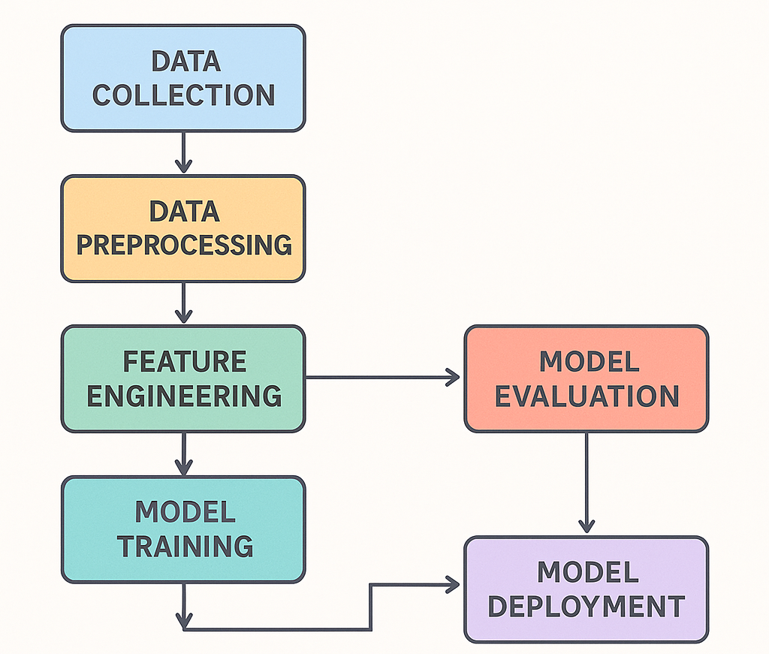
Fig 4.1 Machine Learning workflow

3.11 ER Diagram
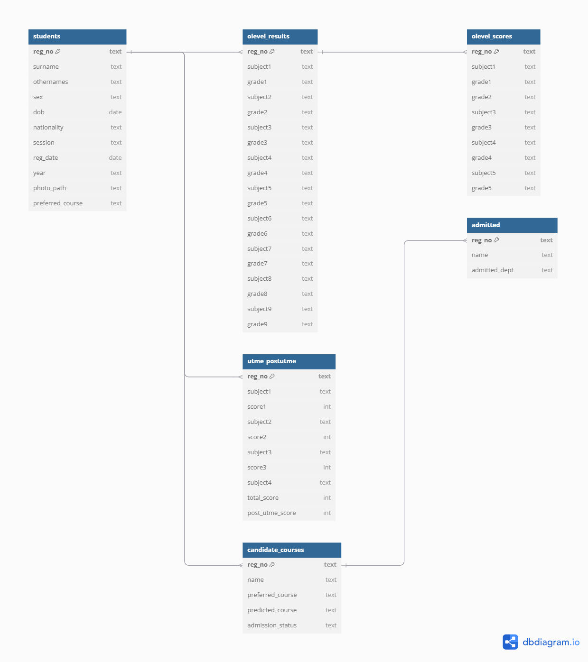Fig 4.2 ER Diagram

3.12 Explanation of Relationships
- students is the core table storing personal data (Bio-data).
- Olevel_result, utme_postutme, and candidate_course tables are linked to students via reg_no (foreign key).
- Each student can have one-to-one entries in olevel utme_postutme, and candidate_course.
- Each student can have one-to-one entries in candidate_course and admitted
- Each student can have one-to-one entries in Olevel_result and Olevel_scores

3.13 UML Diagram
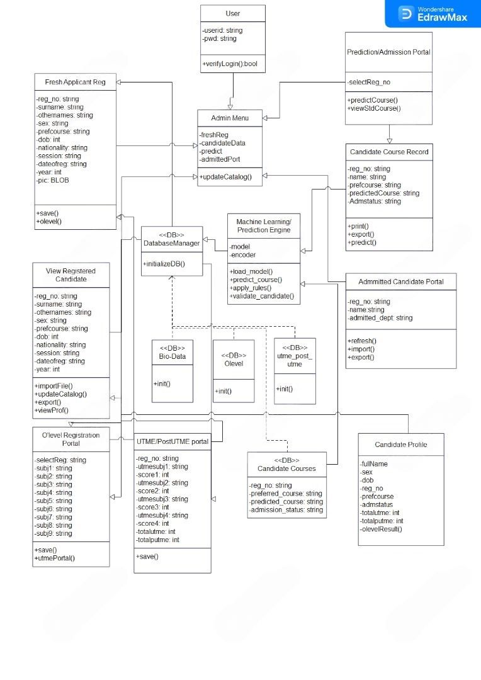
Fig 4.3 UML Diagram

3.15 Interface (UI) Design

3.15.1 Overview
The user interface of the Machine Learning-Based Curriculum Enhancement and Student Admission System is designed with a clean, intuitive, and professional layout tailored for administrative use within an academic environment. The design employs a single-window architecture using Tkinter, ensuring a seamless navigation experience by switching frames within the same window, avoiding multiple pop-ups.

4.5.2 Design Principles
- Consistency: Common UI elements (buttons, labels, fonts) use consistent styling across all screens.
- Responsiveness: The application adapts to a fixed screen size of 1400x1050 ensuring uniformity on academic desktops.
- User Control: Navigation buttons, filters, edit/save controls allow the admin to control the data flow with minimal steps.

4.5.3 Layout Structure

1. Login Screen

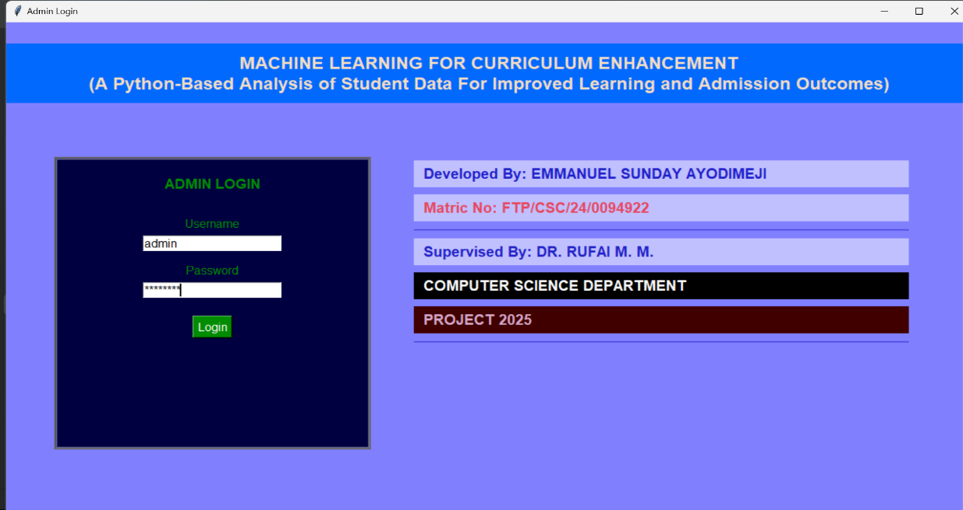
Fig 4.4 Login Screen
Purpose: Authenticate admin access.
Features:
- Username & Password fields
- Error handling for invalid credentials
2. Admin Dashboard
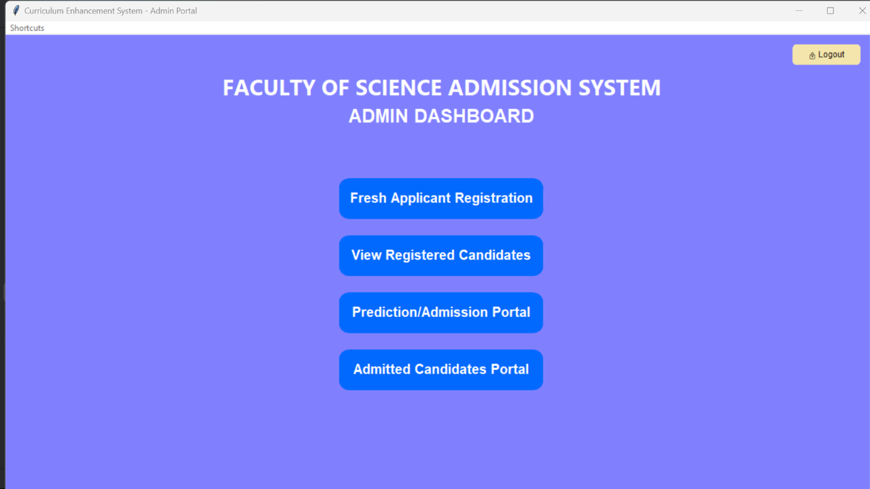
Fig 4.5 Admin Dashboard
Purpose: Provide central access to all features.
Features:
- Top-right Logout button (with icon)
- Menu bar for quick navigation (shortcuts)
- Welcome message and action buttons for:
- Student Registration
- Registered Candidates
- Admitted Candidates Portal

3. Bio-Data Registration Page
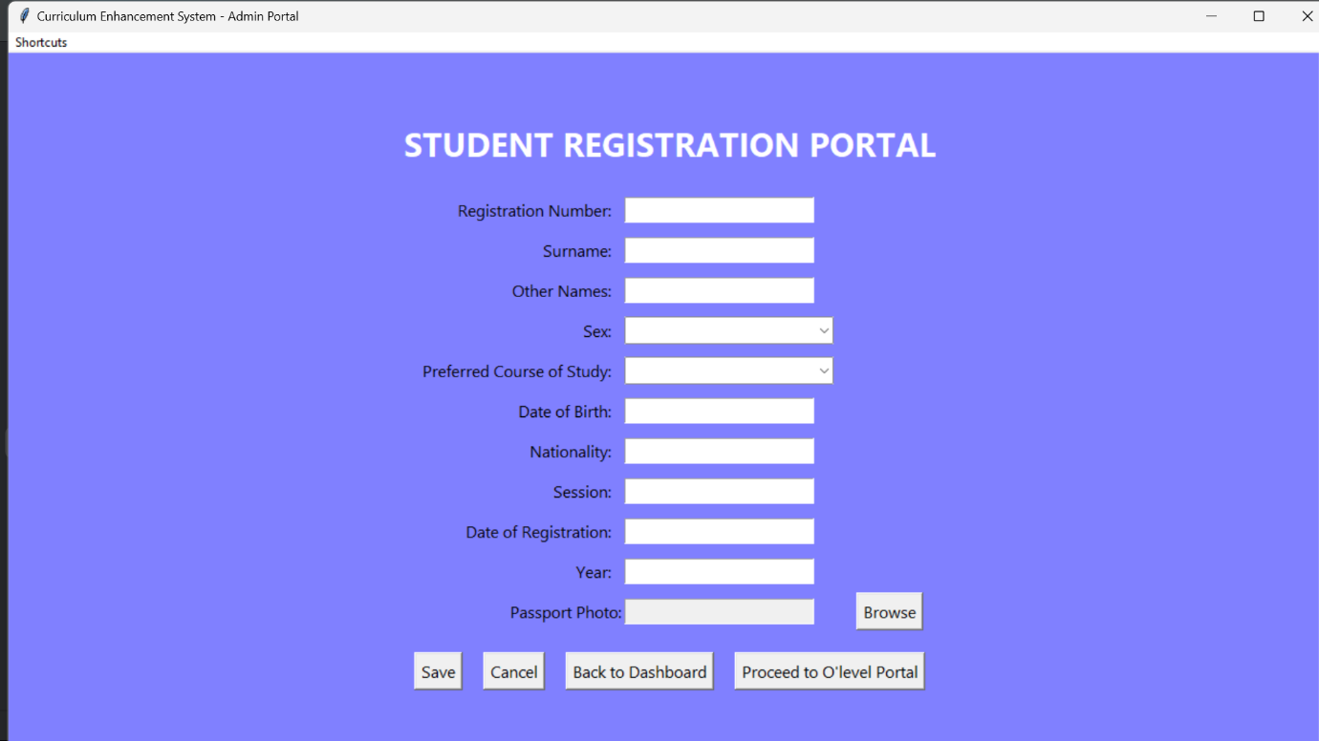
Fig 4.6 Bio-data Registration page
Purpose: Captures student bio-data.
4. O’level Portal
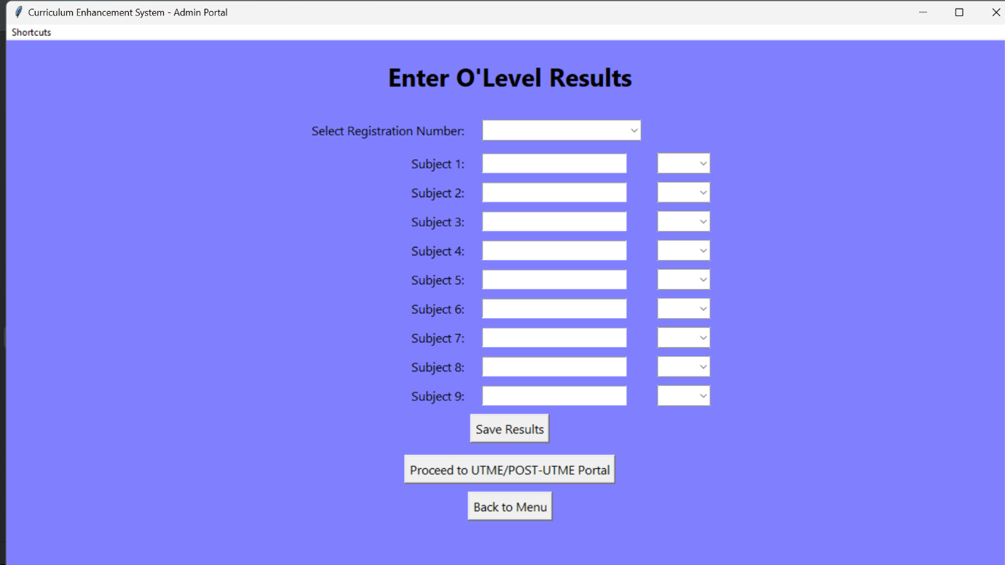
Fig 4.7 O’level Portal
Purpose: Captures student O’level result.
5. UTME/post-UTME Portal
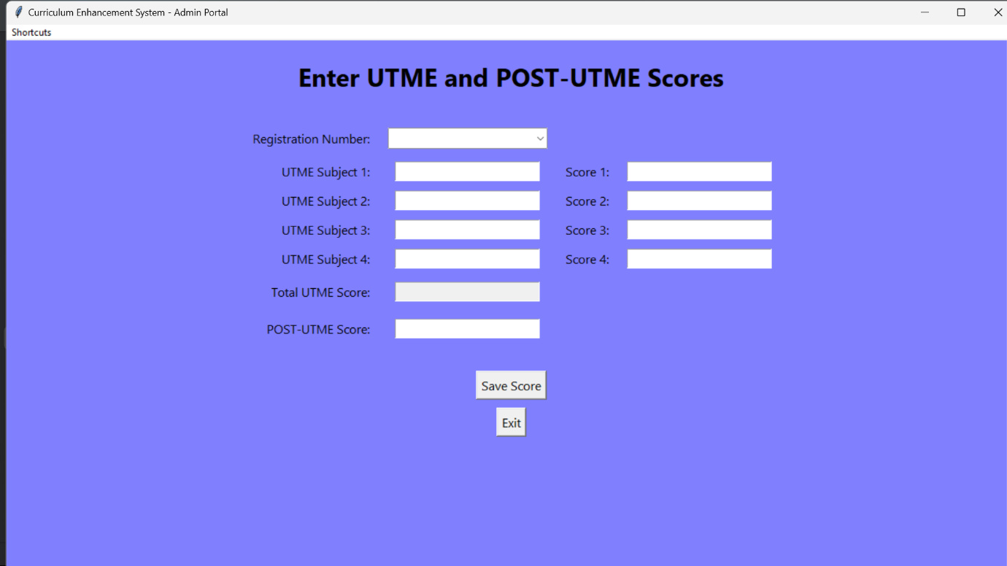Fig 4.8 UTME/postUTME portal
Purpose: Captures student UTME and post-UTME result
6. View Registered Candidate Portal
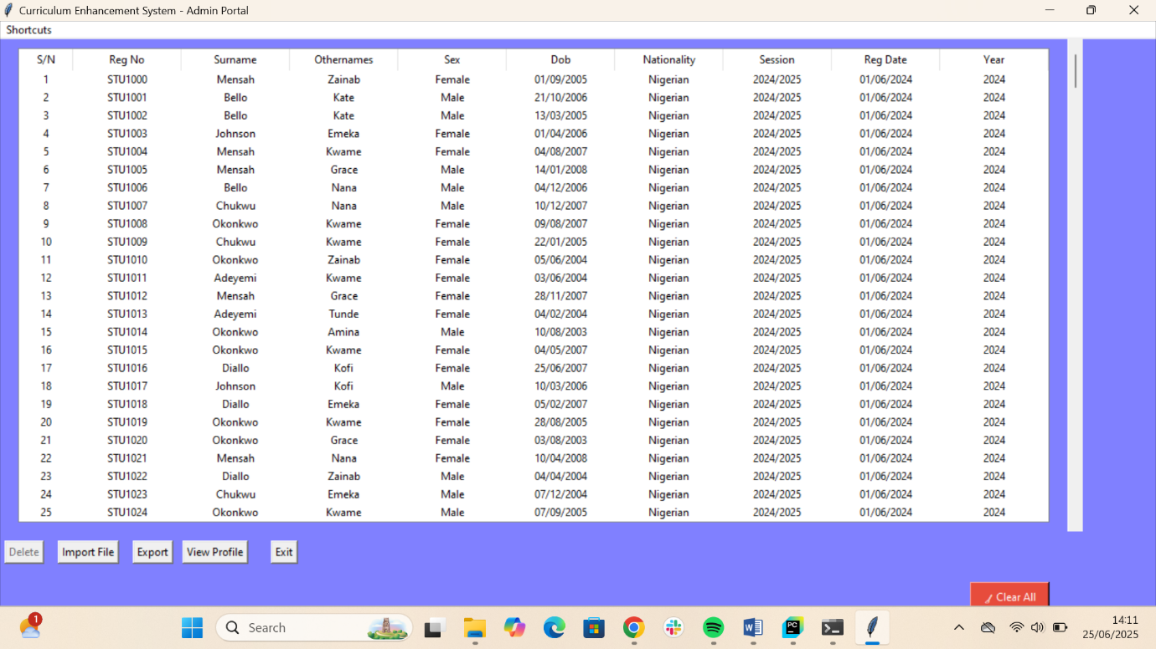Fig 4.9 Registered Candidates Portal

Purpose: Displays all registered candidates.
Features:
- Shows all columns for bio-data
- It has a “View Profile” button to view student’s profile individually when selected
- It has “import file” button that takes structured csv file/data and save the data to their respective columns in the database
- It has “export” button to export the current data entries on the portal in a structured format
- It also has a “delete” button to delete candidate’s data from the database when selected.
7. Student Prediction Portal
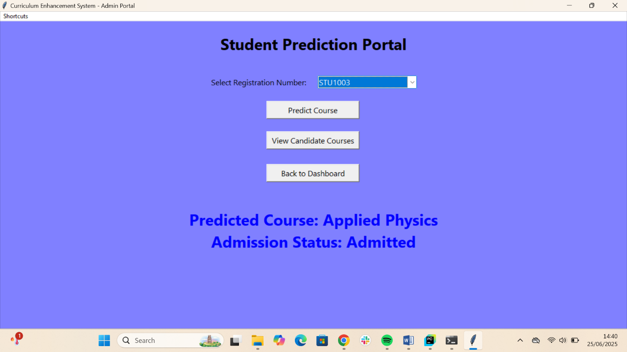Fig 4.10 Student Prediction Portal
Purpose: This is the page where the candidate’s course will be predicted based on the Bio-data, Olevel, UTME, postUTME entries it fetches from the database.
Features:
  - It lets the admin select the candidate’s registration number, and the “predict course” button let the system carry out the prediction and displays the predicted course and admission status on the screen
8. Candidate’s Course Portal
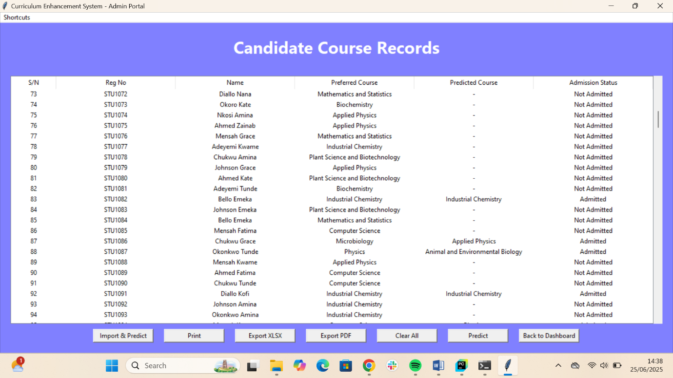Fig 4.11 Candidate’s Course Portal
Purpose: Displays treeview of all registered student, preferred course, predicted course and admission status in the database. and when the “predict” button is clicked, it carries out the prediction for all students on the list and gives the result on their “predicted course” and admission status” row.
Features:
- It has the “predict” button that carries out the prediction for all students on the list and gives the result on their “predicted course” and admission status” row.
- It has export functionalities when the export button is clicked.

9. Admitted Candidates Portal
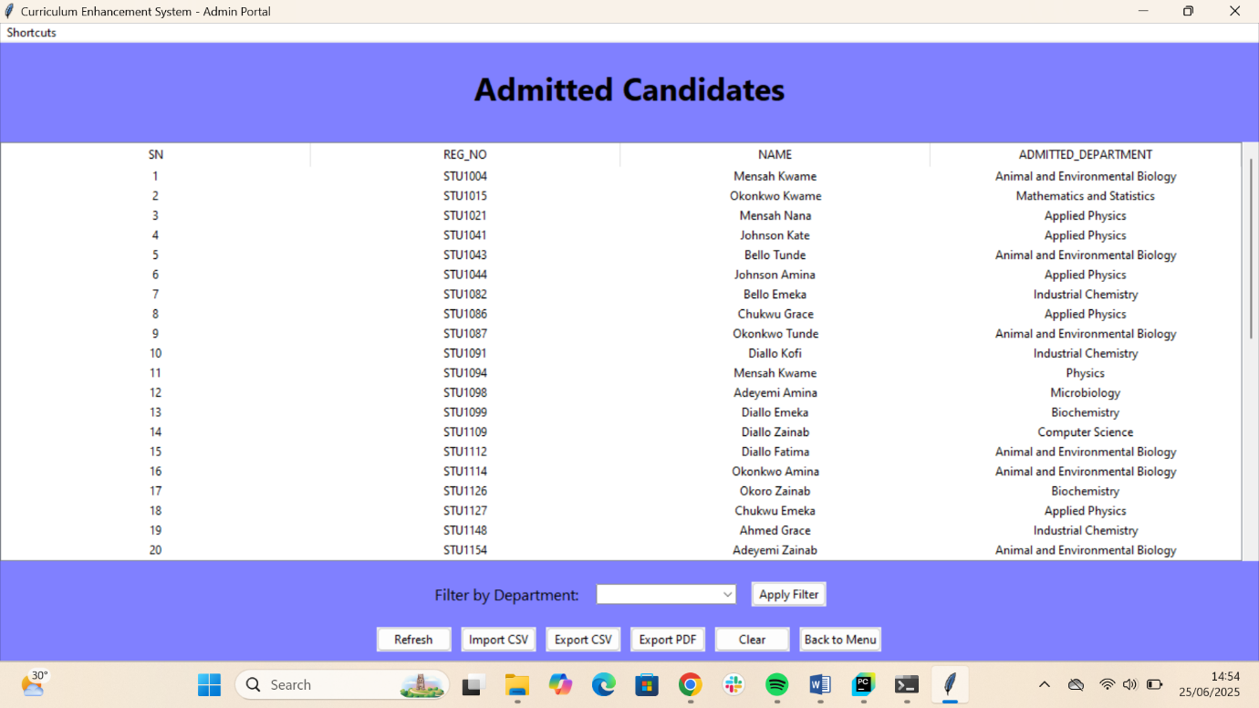Fig 4.12 Admitted Candidate’s Portal
Purpose: Display only the admitted candidates and their predicted course of study.
Features:
- The page fetches the result of the prediction candidate course portal, displays only the admitted candidates and the department they’re being admitted to.
- It has filter functionalities to filter the entries based of their admitted department
- It has import and export functionalities too

CHAPTER FOUR

CHAPTER FOUR
4.0 RESULTS AND DISCUSSION
4.1 Testing Types
To ensure the reliability and correctness of the Curriculum Enhancement System, various types of testing were performed:
4.1.1 Unit Testing
Unit testing focused on verifying the internal logic of individual functions such as:
- Student Registration
- O’level data capturing
- Import file functionalities
And some other core functions too
Mock objects were used to simulate external dependencies like:
- tkinter.Entry and StringVar
- messagebox
- filedialog
- sqlite3.connect
- pandas.read_csv
The following core functions was tested independently using unittest.
Student registration
Test Cases:
- Checks that valid input saves the data and shows a success message.
- Checks that missing registration number triggers an error message.

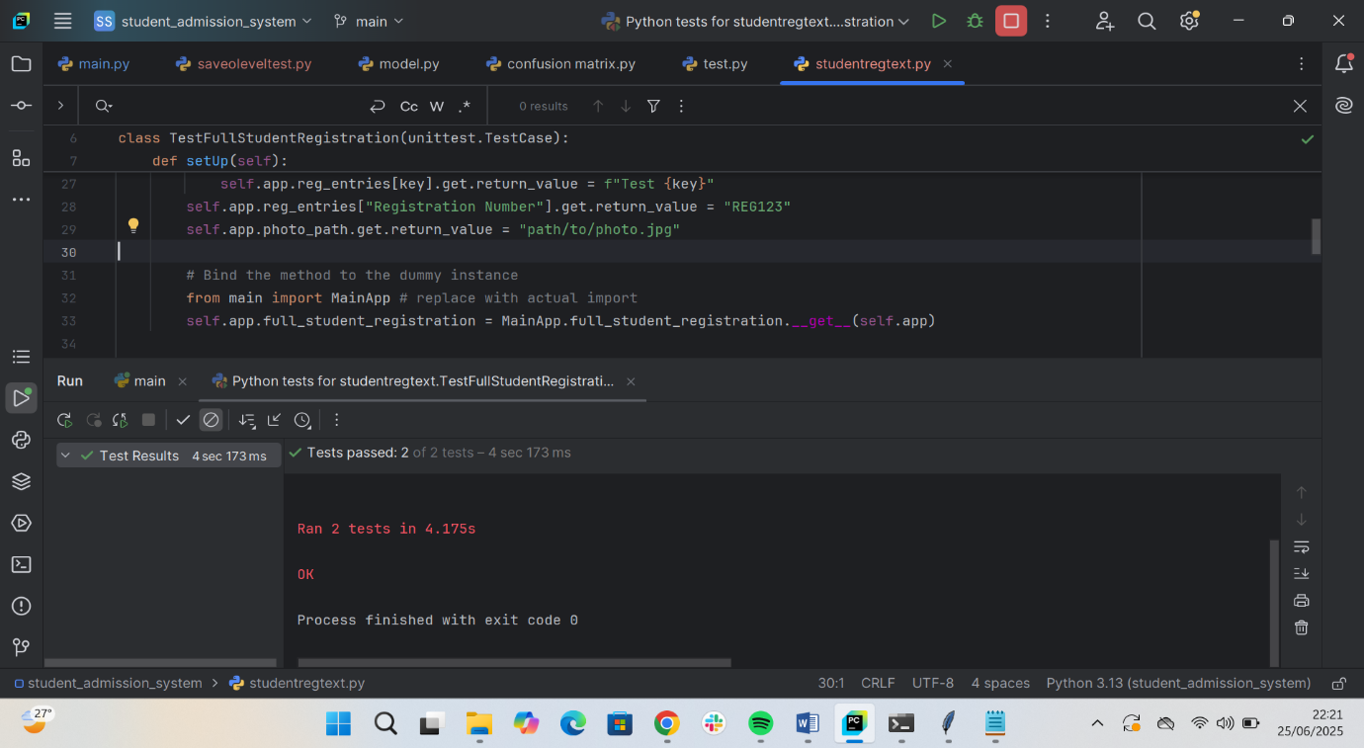
O’level data capturing
Test cases:
- Missing reg number.
- Missing subject or grade.
- Successful save to the database.
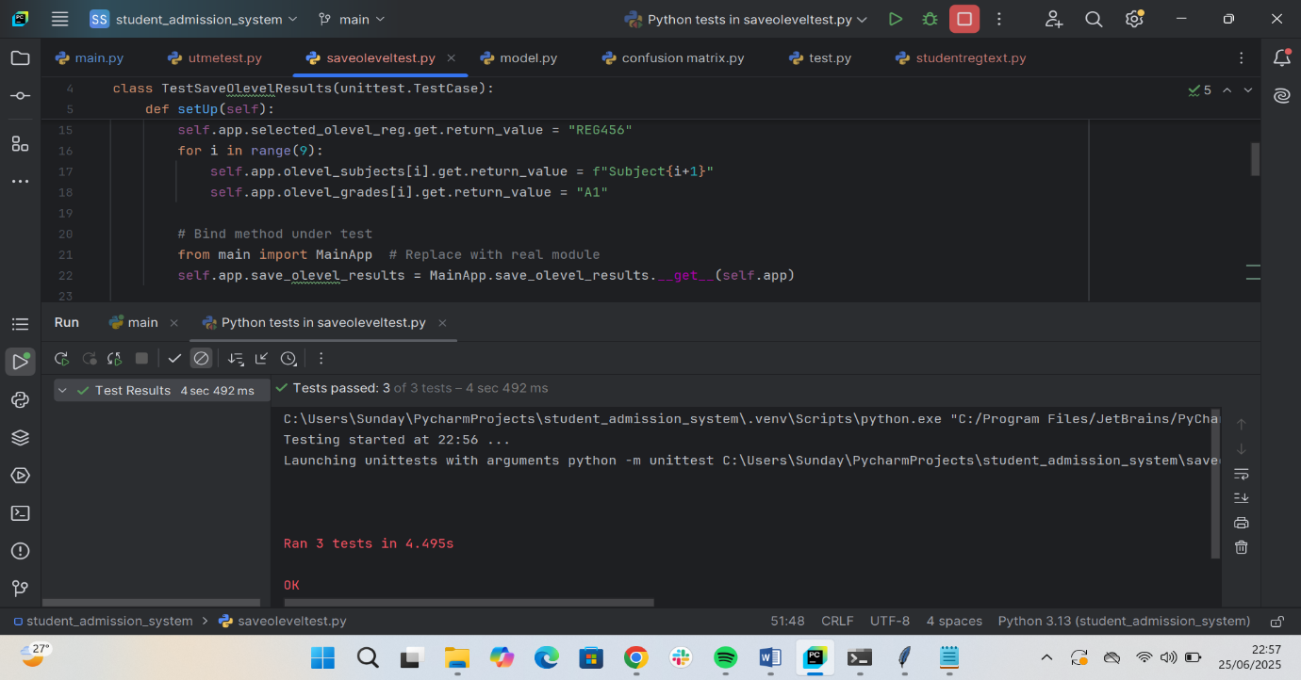

Import File functionalities:
Test cases:
- Shows error if CSV file can’t be read
- Shows error if required columns are missing
- Simulates a proper import and confirms DB calls and success message
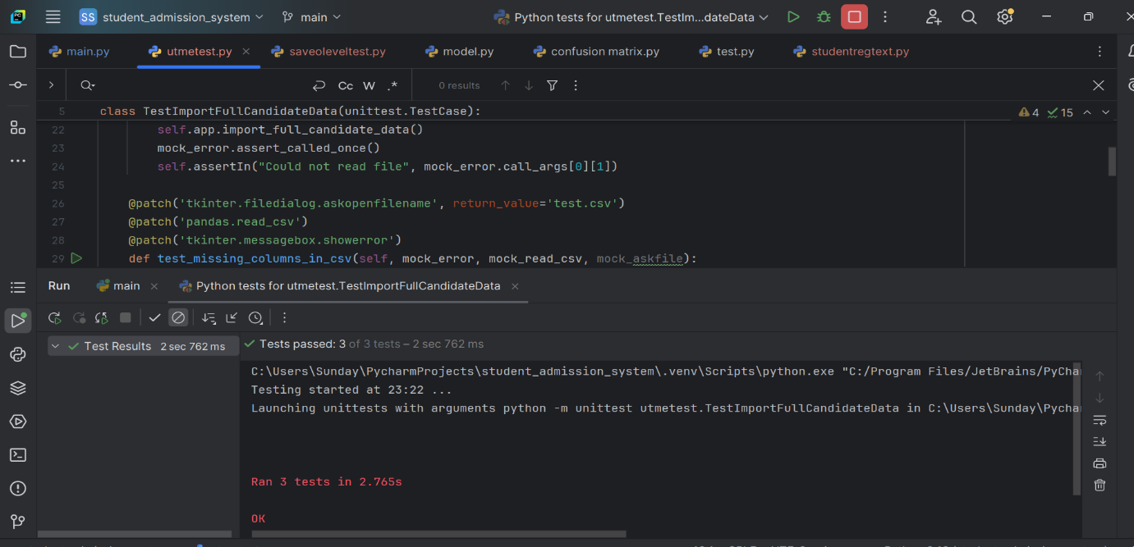

Summary of Other Test Cases and Results
Test Case ID | Test Scenario | Input Data | Expected Result | Actual Result | Status
TC001 | Admin login | Username = admin, Password = admin123 | Login successful, dashboard opens | Login successful, dashboard opens | Pass
TC002 | Predict course | Click Predict button | Fetched necessary data from the database to perform prediction | Predicted course displayed | Pass
TC003 | Export admitted candidates to CSV | Click Export CSV button | CSV file with candidate data is downloaded | CSV file exported successfully | Pass
TC004 | Import from CSV | Structured and valid .csv file of student’s data | Data is loaded and saved into database | Data imported and displayed | Pass
TC005 | Filter admitted candidates by course | Selected department: Computer Science | Only Admitted Computer Science students are shown | Admitted Computer Science students displayed | Pass
TC006 | View Profile | Click view profile button | Display candidates bio-data, Olevel result and UTME/postUTME result | Displayed bio-data, Olevel result and UTME/postUTME result | Pass
TC008 | Logout | Click Logout icon on admin dashboard | Return to login page | Returned to login screen | Pass

4.1.2 Integration Testing
Integration tests were performed to ensure modules like Student Registration, UTME entry, O’level entry, and prediction interact properly. Integration testing focused on validating the end-to-end workflow of the system:
- Form inputs update corresponding database tables
- Prediction logic processes scores and updates candidate status
- Imported CSVs update all related entities across multiple tables
- Data consistency across student, O’Level, UTME/Post-UTME, and candidate courses modules

Test Cases and Results
Test Case ID | Modules Integrated | Scenario Description | Expected Outcome | Status
INT01 | Registration Form → students table | Register student → Check DB for biodata | Row exists in students | Pass
INT02 | O'Level Form → olevel_results(db) | Enter 9 subjects/grades | DB updated | Pass
INT03 | UTME/postUTME form → utme_post_utme(db) | Enter UTME and postUTME subjects and scores | Row exists in students | Pass
INT03 | Students Entry → Prediction Engine | Fetch scores/grades and preferred course → Predict course | Predict and saved predicted course | Pass
INT04 | CSV Import → All DB Tables | Import valid candidate file | All tables populated | Pass
INT05 | Prediction Results → Viewer Portal | Run prediction → View admitted course | Accurate status displayed | Pass

4.2 Performance Evaluation
4.2.1 Empirical Analysis of System Performance with Large Dataset
The performance of a machine learning model is critical to its deployment in real-world applications. In order to assess the performance, speed, and scalability of the student admission system, a comprehensive performance evaluation was conducted using a test dataset comprising 600 student records. The dataset included complete candidate information such as biodata, O’Level subjects and grades, UTME and Post-UTME scores, and preferred courses.
The model has been trained and tested using a synthetic but structured dataset, and the evaluation metrics include accuracy, precision, recall, F1-score, and confusion matrix.
The evaluation focused on key system operations, including:
- Importing the full dataset into the system via CSV
- Executing bulk predictions using the integrated rule-based and machine learning (ML) model
- Assessing GUI responsiveness when displaying candidate records
- Measuring the time taken for database insertions and model inference
4.2.2 Dataset Overview
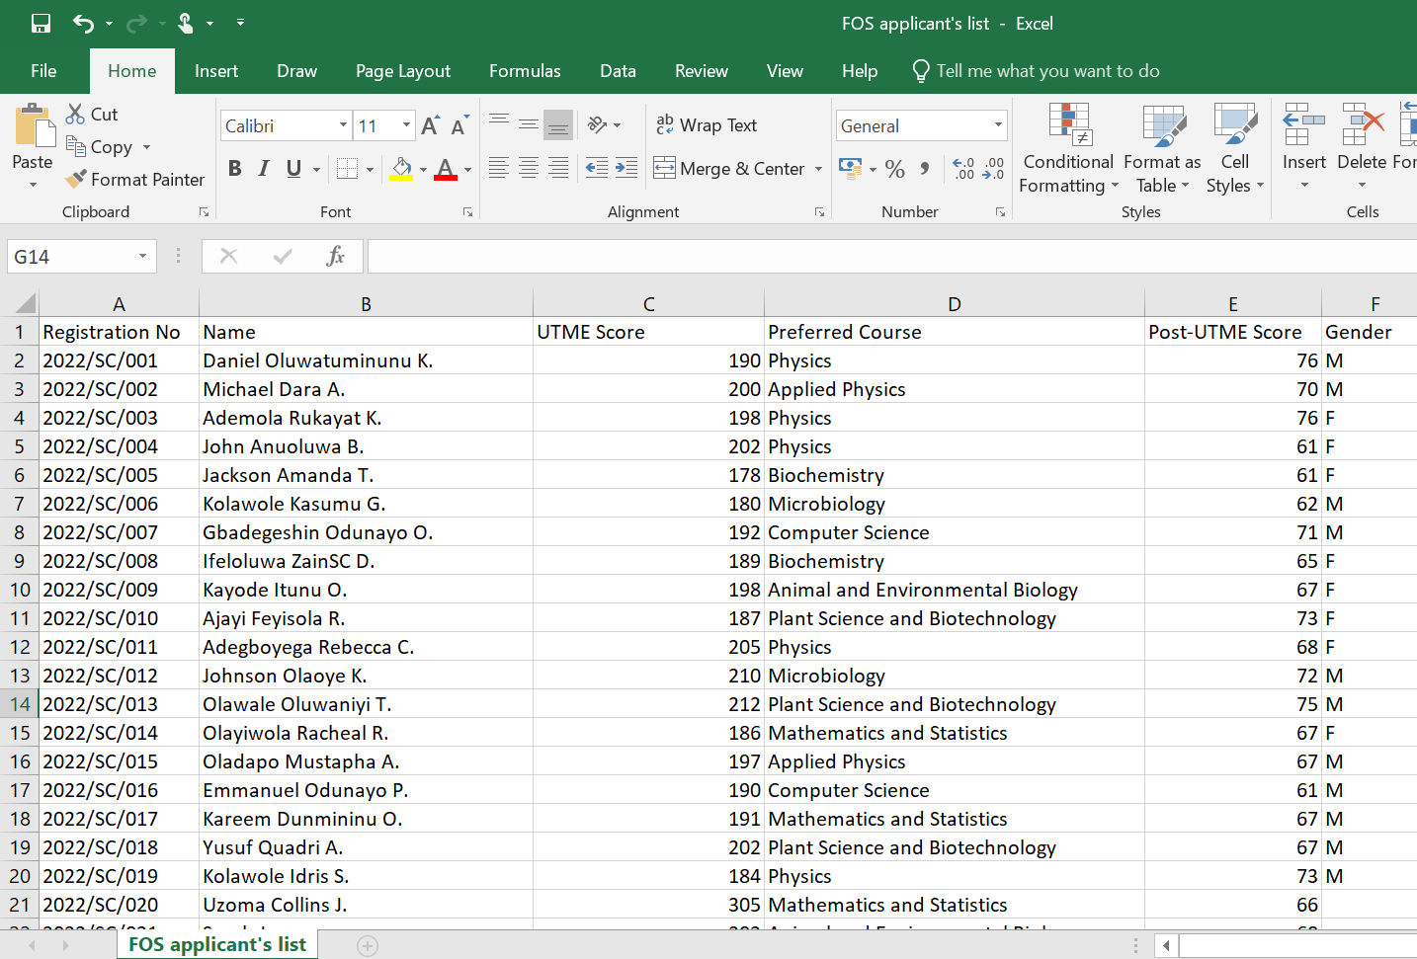
Fig 6.0 Snapshot of Dataset after preprocessing
- Total Test Samples Evaluated: 618 candidates
- Target Classes: 10 (9 valid departments + 1 "Not Admitted" category represented by "-")
- Features Used: UTME Score, Post-UTME Score, and grades in English, Mathematics, Physics, Chemistry, Biology, Agricultural Science, Geography, Economics, and Literature

6.2.3 Evaluation Criteria
Component | Metric | Tool/Method
Import Function | Time to import 1000 records | time.time()
Registration | Save speed for 1 record | time.time()
Prediction Engine | Accuracy, Precision, F1 | sklearn.metrics
Prediction Time | Avg. time per prediction | time.time()
GUI Performance | Time to load display | Manual stopwatch

6.2.4 Test Environment
Property | Details
System | Windows 10, 8GB RAM, Core i5
Python Version | 3.11
GUI Framework | Tkinter
DB | SQLite
ML Library | scikit-learn

6.2.5 Overall Accuracy
Accuracy: 0.795 or 79.5%
This means that the model correctly classified about 80% of the test candidates, either by admitting them to the appropriate department or by correctly identifying them as not admitted ("-").

6.2.6 ML Model Performance (Classification)
Metric | Value
Accuracy | 0.795 (~ 80%)
Precision | 0.75 (75%)
Recall | 0.80 (80%)
F1 Score | 0.77 (77%)
Prediction Speed | ~5.6 seconds for 600 candidates

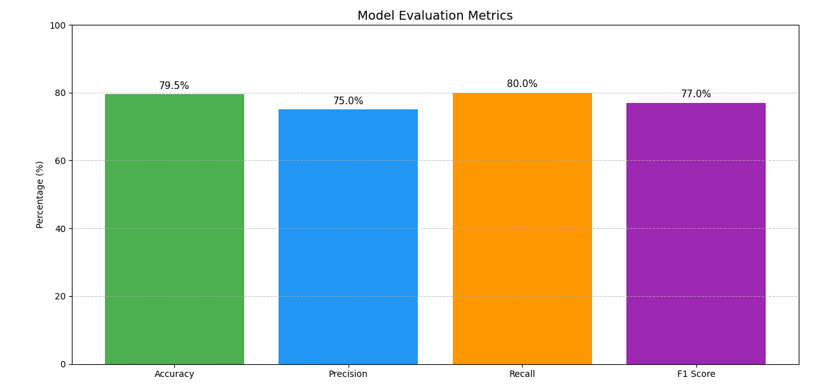

4.3 Results and Discussion

4.3.1 Classification Report Interpretation
Class | Precision | Recall | F1-Score | Support
Not Admitted ("-") | 0.96 | 1.00 | 0.98 | 124
Animal and Environmental Biology | 0.69 | 0.90 | 0.78 | 20
Applied Physics | 0.29 | 0.40 | 0.33 | 10
Biochemistry | 0.50 | 0.33 | 0.40 | 3
Computer Science | 0.80 | 0.80 | 0.80 | 5
Industrial Chemistry | 0.50 | 0.32 | 0.39 | 4
Mathematics and Statistics | 0.57 | 0.40 | 0.47 | 10
Microbiology | 0.25 | 0.20 | 0.22 | 5
Physics | 0.30 | 0.43 | 0.35 | 7
Plant Science and Biotechnology | 0.59 | 0.6 | 0.40 | 5

Key Terms:
- Precision: Of all students predicted to be in a department, how many were actually correct
- Recall: Of all students that actually belong in a department, how many were correctly predicted
- F1-Score: Harmonic mean of precision and recall
- Support: Number of actual samples per class in the test set

4.3.2 Prediction Outputs

The system accurately predicted candidates' most suitable departments based on their O’Level and UTME/POST UTME results.

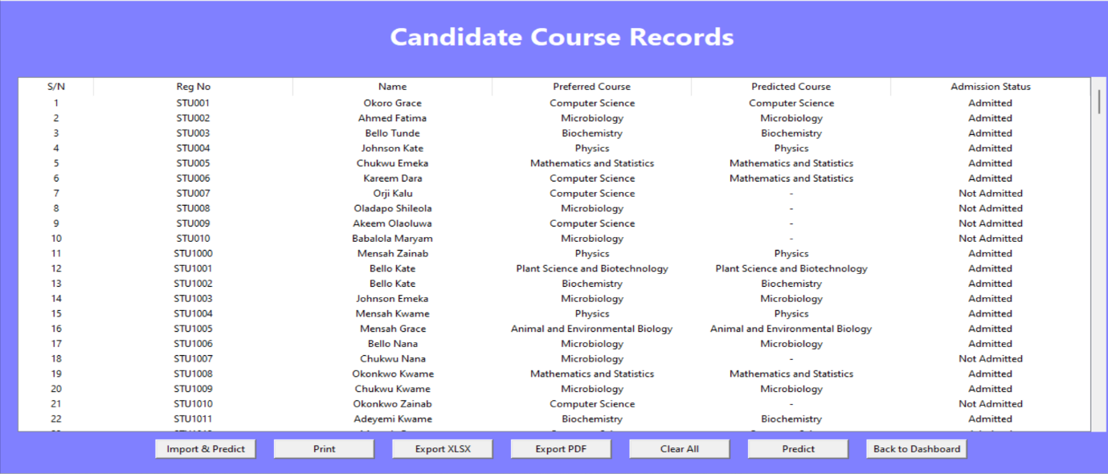

4.3.3 Performance Test Results
Task | Dataset Size | Time Taken | Notes
Import 600 candidate records | 600 rows | 3.2 sec | CSV import tested via GUI
Predict admission for 600 students | 1000 records | 2.6 sec | Model used: RandomForest
Register single student | 1 record | 0.15 sec | GUI + DB write time
Save O’Level scores | 1 record | 0.12 sec | From form to DB
Save UTME/Post-UTME scores | 1 record | 0.14 sec | Measured using time module
Refresh GUI Table (Treeview) | 1000 records | ~1.3 sec | Acceptable UI performance

4.3.4 Discussions of Results
The system demonstrated strong performance in predicting candidate admission outcomes. Dominance of "Not Admitted" predictions was observed, where the model performed extremely well in detecting students who did not qualify, achieving near-perfect precision and recall in this category. This is beneficial for minimizing false positives, although it may also indicate overfitting toward the majority class.
It is important to note that the model was trained using a combination of real student records from Osun State Polytechnic, Iree, and AI-generated synthetic data. The synthetic data helped balance the dataset by addressing under-represented courses and admission outcomes, thereby improving the model’s robustness and fairness. However, evaluation and reported accuracy metrics were calculated primarily on the real institutional dataset to ensure reliability and real-world applicability.
The system handled large candidate datasets efficiently during import and prediction. GUI responsiveness remained stable, even with thousands of records. Mismatches between preferred and predicted courses were mainly due to low performance in critical subjects such as Mathematics or Biology.
4.4 Outcomes of Evaluation And Testing
The student admission system successfully achieved its core objectives. All modules including student registration, O’Level and UTME score entry, data import/export, and machine learning-based course prediction were implemented and thoroughly tested.
Unit testing confirmed that individual components performed reliably, while integration testing validated smooth interaction between modules and accurate data flow. The performance evaluation showed the system is capable of handling real-world admission data, processing 600 candidates in under 6 seconds during import and prediction operations.
The machine learning model achieved a predictive accuracy of 79.5%, with a balanced F1-score of 0.77 (77%), demonstrating strong classification performance. GUI responsiveness remained stable, with all forms loading and submitting data without delays or crashes.
During testing, no major errors were encountered. Minor issues such as input validation for numeric scores were handled gracefully with error messages. The system also supports scaling and can be extended to handle larger datasets with minor optimization.
Overall, the system meets both functional and non-functional requirements and is suitable for deployment in a real academic setting. It provides a practical solution for automating admission decisions, reducing manual errors, and improving administrative efficiency.

CHAPTER FIVE
7.0 CONCLUSION AND RECOMMENDATIONS
7.1 Summary of Results
The student admission system powered by machine learning successfully achieved its core objectives. The Random Forest classification model, based on academic performance data (O’Level, UTME, and Post-UTME scores), attained an accuracy of 79.5% in predicting suitable courses for students.
The integration of AI-generated synthetic data alongside real institutional records provided a more balanced training dataset. This approach reduced bias caused by imbalanced course distributions and improved the system’s prediction stability. Despite this, real student data remained the basis for evaluation to ensure accuracy in practical scenarios.
Key results include:
- High accuracy and efficiency in predicting student course placement.
- Balanced dataset achieved by combining real and AI-generated records.
- Transparent and data-driven admission recommendations.
- Usable interface for admission officers with import/export functionality.

7.2 Project Limitations
Despite the system’s effectiveness and accuracy, several limitations were encountered during development and testing:
- Limited Dataset Size: The machine learning model was trained on a relatively small dataset (1000 rows), which may not fully represent real-world diversity in student performance and behavior.
- Feature Scope Constraints: The model relies primarily on O’Level, UTME, and Post-UTME scores. Other potential factors like student interests, extracurricular activities, or learning style were not considered due to data unavailability.
- Static Course Mapping: Course names and department structures were predefined and hardcoded. Institutions with different naming or admission criteria would require manual adjustments.
- Model Generalization Risk: Since the dataset was simulated, the trained model might not generalize well across different universities or faculties without retraining.
- No Real-Time Online Capability: The system is built as a standalone desktop application using Tkinter and SQLite. It lacks online capabilities such as multi-user access, real-time updates, and cloud storage.
- Basic Security Measures: Login and access control features were minimal. A more secure authentication system (e.g., hashed passwords, role-based access) would be necessary for production use.
7.3 Recommendations
In the future, the system can incorporate larger datasets across multiple faculties and institutions to further reduce dependence on synthetic data. Advanced data augmentation and generative AI techniques (such as SMOTE and GANs) can also be used to simulate diverse academic profiles, making predictions even more reliable.
Additionally, adopting real-time data collection from institutional admission systems would enable continuous model retraining with minimal synthetic supplementation. Expanding the system to web and mobile platforms with cloud-based databases would also enhance scalability, accessibility, and multi-user collaboration.

REFERENCES
Alpaydin, E. (2020). Introduction to machine learning (4th ed.). MIT Press.
Amazon.com. (2005). An overview of data mining techniques. Retrieved October 27, 2006, from http://www.amazon.com/exec/obidos.htm
Amrieh, E. A., Hamtini, T., & Aljarah, I. (2016). Mining educational data to predict student’s academic performance using ensemble methods. International Journal of Database Theory and Application, 9(8), 119–136. https://doi.org/10.14257/ijdta.2016.9.8.13
Anderson, U. (2006). Data mining: What is data mining? Retrieved December 17, 2006, from http://www.anderson.ucla.edu/datamining.htm
Chapman, P., Clinton, J., Kerber, R., Khabaza, T., Thomas, R., Shearer, C., & Wirth, R. (2000). CRISP-DM 1.0 Step-by-step data mining guide. SPSS White Paper Technical Report, CRISP WP-0800.
Dunham, M. H. (2003). Data mining: Introductory and advanced topics. Upper Saddle River, NJ: Pearson Education, Inc.
Edelstein, H. (1997). Data mining: Exploring the hidden trends in your data. DB2 Online Magazine. Available at: http://www.db2mag.com
Efraim, T., Jay, E. A., Tin-Peng, L., & Ramesh, S. (2003). Decision support and business intelligence systems. Pearson Education.
Faker Community. (2024). Faker: Python package for generating fake data. https://faker.readthedocs.io/
Fayyad, U., Piatetsky-Shapiro, G., & Smyth, P. (1996). From data mining to knowledge discovery in databases. AI Magazine, 17(3), 37–54.
Feldman, J., & Tung, R. (2001). Using data-based inquiry and decision making to improve instruction. ERS Spectrum, 19(3), 10+9.
Géron, A. (2019). Hands-On Machine Learning with Scikit-Learn, Keras, and TensorFlow (2nd ed.). O’Reilly Media.
Goodfellow, I., Bengio, Y., & Courville, A. (2016). Deep learning. MIT Press.
Han, J., & Kamber, M. (2001). Data mining: Concepts and techniques. San Diego: Morgan Kaufmann.
Hunter, J. D. (2007). Matplotlib: A 2D graphics environment. Computing in Science & Engineering, 9(3), 90–95.
Jordan, M. I., & Mitchell, T. M. (2015). Machine learning: Trends, perspectives, and prospects. Science, 349(6245), 255–260. https://doi.org/10.1126/science.aaa8415
Kabakchieva, D. (2013). Predicting student performance by using data mining methods for classification. Cybernetics and Information Technologies, 13(1), 61–72. https://doi.org/10.2478/cait-2013-0006
Kohavi, R. (1995). A study of cross-validation and bootstrap for accuracy estimation and model selection. IJCAI, 2, 1137–1143.
Kotsiantis, S. B. (2007). Supervised machine learning: A review of classification techniques. Informatica, 31(3), 249–268. https://doi.org/10.15388/Informatica.2007.174
Lilan, J. (2001). Data mining as driven by knowledge management in higher education: Persistence, clustering, and prediction. Presented at the 2001 SPSS Public Conference, UCSF.
Murphy, K. P. (2022). Probabilistic machine learning: An introduction. MIT Press.
Musso, M. F., Boekaerts, M., Segers, M., & Cascallar, E. (2020). Individual differences in basic cognitive processes and self-regulated learning: Their interaction effects on student’s achievement. Learning and Individual Differences, 80, 101885. https://doi.org/10.1016/j.lindif.2020.101885
Pedregosa, F., Varoquaux, G., Gramfort, A., Michel, V., Thirion, B., Grisel, O., ... & Duchesnay, É. (2011). Scikit-learn: Machine learning in Python. Journal of Machine Learning Research, 12, 2825–2830.
Waskom, M. L. (2021). Seaborn: Statistical data visualization. Journal of Open Source Software, 6(60), 3021.
APPENDIX
PROGRAM CODE
#login.py
class LoginScreen:
def __init__(self, root):
self.root = root
self.root.title("Admin Login")
self.root.geometry(f"{SCREEN_WIDTH}x{SCREEN_HEIGHT}")
self.root.configure(bg="#8080FF") # Page background

# ====== Title/Header ======
title_frame = tk.Frame(self.root, bg="#0269FE", pady=10)
title_frame.pack(fill="x", pady=30)
title_label = tk.Label(
title_frame,
text="MACHINE LEARNING FOR CURRICULUM ENHANCEMENT\n(A Python-Based Analysis of Student Data For Improved Learning and Admission Outcomes)",
font=("Helvetica", 18, "bold"),
bg="#0269FE",
fg="#F3DCC3",
justify="center"
)
title_label.pack()

# ====== Content Frame ======
content_frame = tk.Frame(self.root, bg="#8080FF", padx=40, pady=20)
content_frame.pack(fill="both", expand=True)

# ====== Left: Login Frame ======
login_frame = tk.Frame(content_frame, bg="#000040", bd=2, relief="groove", highlightbackground="#CDCBE3", highlightthickness=2)
login_frame.place(relx=0.02, rely=0.05, relwidth=0.35, relheight=0.8)

tk.Label(login_frame, text="ADMIN LOGIN", font=("Helvetica", 14, "bold"), bg="#000040", fg="#008C01").pack(pady=20)

tk.Label(login_frame, text="Username", font=("Helvetica", 12), bg="#000040", fg="#008C01").pack(pady=(10, 0))
self.username_entry = tk.Entry(login_frame, font=("Helvetica", 12))
self.username_entry.pack(pady=5)

tk.Label(login_frame, text="Password", font=("Helvetica", 12), bg="#000040", fg="#008C01").pack(pady=(10, 0))
self.password_entry = tk.Entry(login_frame, show="*", font=("Helvetica", 12))
self.password_entry.pack(pady=5)

tk.Button(login_frame, text="Login", font=("Helvetica", 12), bg="#008C01", fg="white", command=self.login).pack(pady=20)

# ====== Right: Developer Info Frame ======
right_frame = tk.Frame(content_frame, bg="#8080FF")
right_frame.place(relx=0.4, rely=0.05, relwidth=0.58, relheight=0.8)

info = [
("Developed By: ", "EMMANUEL SUNDAY AYODIMEJI", "#C0C0FF", "#2121CB"),
("Matric No: ", "FTP/CSC/24/0094922", "#C0C0FF", "#E8485F"),
("Supervised By: ", "DR. RUFAI M. M.", "#C0C0FF", "#2323C7"),
("COMPUTER SCIENCE DEPARTMENT", "", "#000000", "#F9F9FA"),
("PROJECT 2025", "", "#400000", "#D6A6C8")
]

for i, (label, value, bg, fg) in enumerate(info):
container = tk.Frame(right_frame, bg=bg)
container.pack(fill="x", pady=5, padx=20)
text = label + value
tk.Label(
container,
text=text,
font=("Helvetica", 15, "bold"),
bg=bg,
fg=fg
).pack(anchor="w", padx=10, pady=4)

if i in [1, 4]: # breaklines after Matric No and Department
tk.Frame(right_frame, bg="#4F4FE7", height=2).pack(fill="x", pady=6, padx=20)

def login(self):
user = self.username_entry.get()
pwd = self.password_entry.get()
if user == "admin" and pwd == "admin123":
self.root.destroy()
app = tk.Tk()
MainApp(app)
app.mainloop()
else:
messagebox.showerror("Login Failed", "Invalid credentials")

#Studentregistration.py
def full_student_registration(self):
import sqlite3

biodata = {label: entry.get().strip() for label, entry in self.reg_entries.items()}
biodata["Photo"] = self.photo_path.get()

if not biodata["Registration Number"]:
messagebox.showerror("Missing Data", "Registration Number is required.")
return

try:
conn = sqlite3.connect("students.db")
cursor = conn.cursor()
cursor.execute('''
INSERT OR REPLACE INTO students (
reg_no, surname, othernames, sex, preferred_course,
dob, nationality, session, reg_date, year, photo_path
) VALUES (?, ?, ?, ?, ?, ?, ?, ?, ?, ?, ?)
''', (
biodata['Registration Number'], biodata['Surname'], biodata['Other Names'], biodata['Sex'],
biodata['Preferred Course of Study'], biodata['Date of Birth'], biodata['Nationality'],
biodata['Session'], biodata['Date of Registration'], biodata['Year'], biodata['Photo']
))
conn.commit()
conn.close()
messagebox.showinfo("Success", "Student bio data saved successfully.")
self.clear_entries()
except Exception as e:
messagebox.showerror("Database Error", str(e))

def full_student_registration(self):
import sqlite3

biodata = {label: entry.get().strip() for label, entry in self.reg_entries.items()}
biodata["Photo"] = self.photo_path.get()

if not biodata["Registration Number"]:
messagebox.showerror("Missing Data", "Registration Number is required.")
return

try:
conn = sqlite3.connect("students.db")
cursor = conn.cursor()
cursor.execute('''
INSERT OR REPLACE INTO students (
reg_no, surname, othernames, sex, preferred_course,
dob, nationality, session, reg_date, year, photo_path
) VALUES (?, ?, ?, ?, ?, ?, ?, ?, ?, ?, ?)
''', (
biodata['Registration Number'], biodata['Surname'], biodata['Other Names'], biodata['Sex'],
biodata['Preferred Course of Study'], biodata['Date of Birth'], biodata['Nationality'],
biodata['Session'], biodata['Date of Registration'], biodata['Year'], biodata['Photo']
))
conn.commit()
conn.close()
messagebox.showinfo("Success", "Student bio data saved successfully.")
self.clear_entries()
except Exception as e:
messagebox.showerror("Database Error", str(e))

#show_utme_portal.py
def show_utme_portal(self):
self.clear_current_frame() # Clear previous content
self.current_frame = tk.Frame(self.root, bg=BG_COLOR)
self.current_frame.pack(fill="both", expand=True)

tk.Label(self.current_frame, text="Enter UTME and POST-UTME Scores", font=FONT_HEADER, bg=BG_COLOR).pack(
pady=20)

form_frame = tk.Frame(self.current_frame, bg=BG_COLOR)
form_frame.pack(pady=10)

# Select student
tk.Label(form_frame, text="Registration Number:", font=FONT_NORMAL, bg=BG_COLOR).grid(row=0, column=0,
sticky='e', padx=10,
pady=10)

conn = sqlite3.connect("students.db")
cursor = conn.cursor()
cursor.execute("SELECT reg_no FROM students")
reg_nos = [row[0] for row in cursor.fetchall()]
conn.close()

selected_reg = tk.StringVar()
reg_combo = ttk.Combobox(form_frame, textvariable=selected_reg, values=reg_nos, font=FONT_NORMAL,
state="readonly")
reg_combo.grid(row=0, column=1, padx=10, pady=10)

# UTME subjects and scores
utme_subjects = []
utme_scores = []
for i in range(4):
tk.Label(form_frame, text=f"UTME Subject {i + 1}:", font=FONT_NORMAL, bg=BG_COLOR).grid(row=i + 1, column=0,
sticky='e', padx=10,
pady=5)
subj = tk.Entry(form_frame, font=FONT_NORMAL)
subj.grid(row=i + 1, column=1, padx=10, pady=5)
utme_subjects.append(subj)

tk.Label(form_frame, text=f"Score {i + 1}:", font=FONT_NORMAL, bg=BG_COLOR).grid(row=i + 1, column=2,
sticky='e', padx=10,
pady=5)
score = tk.Entry(form_frame, font=FONT_NORMAL)
score.grid(row=i + 1, column=3, padx=10, pady=5)
utme_scores.append(score)

# Total UTME Score
tk.Label(form_frame, text="Total UTME Score:", font=FONT_NORMAL, bg=BG_COLOR).grid(row=5, column=0, sticky='e',
padx=10, pady=10)
total_score_var = tk.StringVar()
total_score_entry = tk.Entry(form_frame, textvariable=total_score_var, font=FONT_NORMAL, state='readonly')
total_score_entry.grid(row=5, column=1, padx=10, pady=10)

# POST-UTME Score
tk.Label(form_frame, text="POST-UTME Score:", font=FONT_NORMAL, bg=BG_COLOR).grid(row=6, column=0, sticky='e',
padx=10, pady=10)
postutme_score = tk.Entry(form_frame, font=FONT_NORMAL)
postutme_score.grid(row=6, column=1, padx=10, pady=10)

# Update total score dynamically
def update_total_score(event=None):
total = 0
for entry in utme_scores:
try:
val = int(entry.get())
total += val
except ValueError:
continue
total_score_var.set(str(total))

for score_entry in utme_scores:
score_entry.bind("<KeyRelease>", update_total_score)

# Save data
def save_scores():
reg = selected_reg.get()
if not reg:
messagebox.showerror("Error", "Please select a student.")
return
try:
utme_data = [(subj.get(), int(score.get())) for subj, score in zip(utme_subjects, utme_scores)]
total_score = sum(score for _, score in utme_data)
post_score = int(postutme_score.get())
except ValueError:
messagebox.showerror("Error", "Please ensure all scores are valid numbers.")
return

conn = sqlite3.connect("students.db")
cursor = conn.cursor()
cursor.execute('''
CREATE TABLE IF NOT EXISTS utme_postutme (
reg_no TEXT PRIMARY KEY,
subject1 TEXT, score1 INTEGER,
subject2 TEXT, score2 INTEGER,
subject3 TEXT, score3 INTEGER,
subject4 TEXT, score4 INTEGER,
total_score INTEGER,
post_utme_score INTEGER
)
''')
values = [reg]
for subject, score in utme_data:
values.extend([subject, score])
values.extend([total_score, post_score])
cursor.execute('''
INSERT OR REPLACE INTO utme_postutme (
reg_no, subject1, score1, subject2, score2,
subject3, score3, subject4, score4, total_score, post_utme_score
) VALUES (?, ?, ?, ?, ?, ?, ?, ?, ?, ?, ?)
''', values)
conn.commit()
conn.close()
messagebox.showinfo("Success", f"UTME and POST-UTME scores saved for {reg}")
self.show_main_menu() # Navigate back

# Buttons
button_frame = tk.Frame(self.current_frame, bg=BG_COLOR)
button_frame.pack(pady=20)
tk.Button(button_frame, text="Save Score", font=FONT_NORMAL, command=save_scores).grid(row=0, column=0, padx=10)
tk.Button(button_frame, text="Exit", font=FONT_NORMAL, command=self.show_main_menu).grid(row=1, column=0,

#import_candidate_prediction_data
def import_candidate_prediction_data(self):
from tkinter import filedialog, messagebox
import pandas as pd
import joblib
import sqlite3

# Load trained model and label encoder
try:
model = joblib.load("admission_model.pkl")
le = joblib.load("label_encoder.pkl")
except Exception as e:
messagebox.showerror("Model Error", f"Failed to load model or encoder:\n{e}")
return

file_path = filedialog.askopenfilename(
filetypes=[("CSV Files", "*.csv"), ("Excel Files", "*.xlsx")],
title="Select Candidate Data File"
)
if not file_path:
return

try:
df = pd.read_csv(file_path) if file_path.endswith('.csv') else pd.read_excel(file_path)
except Exception as e:
messagebox.showerror("File Error", f"Could not read file:\n{e}")
return

required_cols = ['reg_no', 'name', 'preferred_course']
if not all(col in df.columns for col in required_cols):
messagebox.showerror("Format Error", "File must contain: reg_no, name, preferred_course")
return

conn = sqlite3.connect("students.db")
cursor = conn.cursor()
successful = 0

grade_map = {
"A1": 8, "B2": 7, "B3": 6,
"C4": 5, "C5": 4, "C6": 3,
"D7": 2, "E8": 1, "F9": 0
}

for _, row in df.iterrows():
reg_no = row['reg_no']
name = row['name']
preferred = row['preferred_course']

# Fetch scores
cursor.execute("SELECT total_score, post_utme_score FROM utme_postutme WHERE reg_no=?", (reg_no,))
utme_row = cursor.fetchone()
if not utme_row:
continue
total_utme, post_utme = utme_row

# Fetch O'Level results
cursor.execute("""
SELECT grade1, grade2, grade3, grade4, grade5, grade6, grade7, grade8
FROM olevel_results WHERE reg_no=?
""", (reg_no,))
olevel_row = cursor.fetchone()
if not olevel_row:
continue

numeric_grades = [grade_map.get(str(g).upper(), 0) for g in olevel_row]

try:
features_df = pd.DataFrame([{
'UTME': total_utme,
'Post-UTME': post_utme,
'English': numeric_grades[0],
'Maths': numeric_grades[1],
'Physics': numeric_grades[2],
'Chemistry': numeric_grades[3],
'Biology': numeric_grades[4],
'Agric': numeric_grades[5]
}])

predicted_code = model.predict(features_df)[0]
predicted_course = le.inverse_transform([predicted_code])[0]

qualifies = (
total_utme > 200 and
post_utme > 60 and
all(g >= 3 for g in numeric_grades[:6])
)

final_course = preferred if qualifies else predicted_course
admission_status = "Admitted" if qualifies or final_course == predicted_course else "Not Admitted"
if admission_status == "Not Admitted":
final_course = "-"

cursor.execute("""
INSERT OR REPLACE INTO candidate_courses
(reg_no, name, preferred_course, predicted_course, admission_status)
VALUES (?, ?, ?, ?, ?)
""", (reg_no, name, preferred, final_course, admission_status))
successful += 1

except Exception as e:
print(f"Prediction error for {reg_no}: {e}")
continue

conn.commit()
conn.close()
self.load_candidate_courses_data()
messagebox.showinfo("Import Complete", f"{successful} candidates successfully imported and predicted.")

#predict_admissions.py
def predict_admissions(self):
import pandas as pd
import sqlite3
import joblib

try:
# Load trained model and encoder
model = joblib.load("admission_model.pkl")
label_encoder = joblib.load("label_encoder.pkl")

# Grade mapping
grade_map = {
"A1": 8, "B2": 7, "B3": 6,
"C4": 5, "C5": 4, "C6": 3,
"D7": 2, "E8": 1, "F9": 0
}

# Connect to DB
conn = sqlite3.connect("students.db")
cursor = conn.cursor()

# Fetch scores table
cursor.execute("SELECT * FROM scores")
rows = cursor.fetchall()
columns = [desc[0] for desc in cursor.description]
df = pd.DataFrame(rows, columns=columns)

if df.empty:
messagebox.showwarning("Warning", "No score data found.")
return

# Convert O'Level grades to numeric
subjects = ['English', 'Maths', 'Physics', 'Chemistry', 'Biology', 'Agric']
for subject in subjects:
df[subject] = df[subject].map(grade_map)

# Prepare data for prediction
X = df[['utme_score', 'post_utme_score'] + subjects].copy()

# Rename to match model’s training feature names
X.rename(columns={
"utme_score": "UTME Score",
"post_utme_score": "Post-UTME Score"
}, inplace=True)

reg_nos = df['reg_no'].tolist()
predicted_codes = model.predict(X)
predicted_courses = label_encoder.inverse_transform(predicted_codes)

# ✅ Course-specific admission check function
def check_admission(course, utme, putme):
cutoffs = {
"Computer Science": (239, 74),
"Biochemistry": (220, 68),
"Microbiology": (210, 65),
"Plant Science and Biotechnology": (200, 60),
}
general_utme = 200
general_putme = 60

if utme < general_utme or putme < general_putme:
return "Not Admitted"

required_utme, required_putme = cutoffs.get(course, (200, 60))
return "Admitted" if utme >= required_utme and putme >= required_putme else "Not Admitted"

# Save predictions + admission decision
for i in range(len(df)):
reg_no = reg_nos[i]
course = predicted_courses[i]
utme = df.loc[i, 'utme_score']
putme = df.loc[i, 'post_utme_score']
admission_status = check_admission(course, utme, putme)

# Fetch name and preferred course
cursor.execute("SELECT surname, othernames, preferred_course FROM students WHERE reg_no = ?", (reg_no,))
info = cursor.fetchone()
if info:
surname, othernames, preferred_course = info
full_name = f"{surname} {othernames}"
else:
full_name = "Unknown"
preferred_course = "Unknown"

# Insert or update candidate course record
cursor.execute("""
INSERT OR REPLACE INTO candidate_courses (
reg_no, name, preferred_course, predicted_course, admission_status
) VALUES (?, ?, ?, ?, ?)
""", (reg_no, full_name, preferred_course, course, admission_status))

conn.commit()
conn.close()

self.load_candidate_courses_data() # Refresh treeview

except Exception as e:
messagebox.showerror("Prediction Error", f"❌ Prediction failed:\n{e}")

#show_full_profile.py
def show_full_profile(self):
selected = self.tree.focus()
if not selected:
messagebox.showwarning("No Selection", "Please select a candidate from the list.")
return

columns = self.tree["columns"]
try:
reg_index = columns.index("reg_no")
except ValueError:
messagebox.showerror("Column Error", "'reg_no' column not found in the Treeview.")
return

reg_no = str(self.tree.item(selected)['values'][reg_index]).strip().upper()

self.clear_current_frame()
self.current_frame = tk.Frame(self.root, bg=BG_COLOR)
self.current_frame.pack(fill="both", expand=True)

# === SCROLLABLE CANVAS IN THIS PAGE ONLY ===
canvas = tk.Canvas(self.current_frame, bg=BG_COLOR)
canvas.pack(side="left", fill="both", expand=True)

scrollbar = tk.Scrollbar(self.current_frame, orient="vertical", command=canvas.yview)
scrollbar.pack(side="right", fill="y")

canvas.configure(yscrollcommand=scrollbar.set)

scrollable_frame = tk.Frame(canvas, bg=BG_COLOR)
canvas.create_window((0, 0), window=scrollable_frame, anchor="nw")

def on_frame_configure(event):
canvas.configure(scrollregion=canvas.bbox("all"))

scrollable_frame.bind("<Configure>", on_frame_configure)
canvas.bind("<MouseWheel>", lambda event: canvas.yview_scroll(int(-1 * (event.delta / 120)), "units"))

# === PAGE CONTENT BELOW ===

tk.Label(scrollable_frame, text=f"Candidate Full Profile - {reg_no}", font=FONT_HEADER, bg=BG_COLOR).pack(
pady=10)

BASE_DIR = os.path.dirname(os.path.abspath(__file__))
db_path = os.path.join(BASE_DIR, "students.db")
conn = sqlite3.connect(db_path)
cursor = conn.cursor()

# === Bio Data ===
bio_frame = tk.LabelFrame(scrollable_frame, text="Bio Data", bg=BG_COLOR, padx=10, pady=10)
bio_frame.pack(fill="x", padx=20, pady=10)

try:
cursor.execute("""
SELECT surname || ' ' || othernames AS full_name, sex, dob
FROM students WHERE reg_no=?
""", (reg_no,))
bio_data = cursor.fetchone()

cursor.execute("""
SELECT preferred_course, admission_status
FROM candidate_courses WHERE reg_no=?
""", (reg_no,))
admission_data = cursor.fetchone()

labels = ["Full Name:", "Sex:", "Date of Birth:", "Registration No.:", "Preferred Course:",
"Admission Status:"]
values = list(bio_data if bio_data else ["N/A"] * 3)
values.append(reg_no)
values.extend(admission_data if admission_data else ["N/A", "N/A"])

for i, label in enumerate(labels):
tk.Label(bio_frame, text=label, bg=BG_COLOR, anchor="w", width=20).grid(row=i, column=0, sticky="w")
tk.Label(bio_frame, text=values[i], bg=BG_COLOR, anchor="w").grid(row=i, column=1, sticky="w")
except Exception as e:
tk.Label(bio_frame, text=f"Error: {str(e)}", bg=BG_COLOR, fg="red").grid(row=0, column=0, columnspan=2,
sticky="w")

# === UTME and Post-UTME Scores ===
scores_frame = tk.LabelFrame(scrollable_frame, text="UTME and Post-UTME Scores", bg=BG_COLOR, padx=10, pady=10)
scores_frame.pack(fill="x", padx=20, pady=10)

try:
cursor.execute("""
SELECT total_score, post_utme_score
FROM utme_postutme WHERE reg_no=?
""", (reg_no,))
scores_data = cursor.fetchone()

if scores_data:
tk.Label(scores_frame, text="Total UTME Score:", bg=BG_COLOR, anchor="w", width=20).grid(row=0,
column=0,
sticky="w")
tk.Label(scores_frame, text=scores_data[0] or "N/A", bg=BG_COLOR, anchor="w").grid(row=0, column=1,
sticky="w")

tk.Label(scores_frame, text="Post-UTME Score:", bg=BG_COLOR, anchor="w", width=20).grid(row=1, column=0,
sticky="w")
tk.Label(scores_frame, text=scores_data[1] or "N/A", bg=BG_COLOR, anchor="w").grid(row=1, column=1,
sticky="w")
else:
tk.Label(scores_frame, text="No UTME/Post-UTME scores found", bg=BG_COLOR, fg="red").grid(row=0,
column=0,
columnspan=2,
sticky="w")
except Exception as e:
tk.Label(scores_frame, text=f"Error loading scores: {str(e)}", bg=BG_COLOR, fg="red").grid(row=0, column=0,
columnspan=2,
sticky="w")

# === O'Level Results ===
olevel_frame = tk.LabelFrame(scrollable_frame, text="O'Level Results", bg=BG_COLOR, padx=10, pady=10)
olevel_frame.pack(fill="x", padx=20, pady=10)

try:
cursor.execute("""
SELECT subject1, grade1, subject2, grade2, subject3, grade3,
subject4, grade4, subject5, grade5, subject6, grade6,
subject7, grade7, subject8, grade8, subject9, grade9
FROM olevel_results WHERE reg_no=?
""", (reg_no,))
olevel_data = cursor.fetchone()

if olevel_data:
for i in range(9):
subject = olevel_data[i * 2] or "N/A"
grade = olevel_data[i * 2 + 1] or "N/A"
tk.Label(olevel_frame, text=f"{subject}:", bg=BG_COLOR, anchor="w", width=20).grid(row=i, column=0,
sticky="w")
tk.Label(olevel_frame, text=grade, bg=BG_COLOR, anchor="w").grid(row=i, column=1, sticky="w")
else:
tk.Label(olevel_frame, text="No O'Level Results Found", bg=BG_COLOR, fg="red").grid(row=0, column=0,
columnspan=2,
sticky="w")
except Exception as e:
tk.Label(olevel_frame, text=f"Error loading O'Level data: {str(e)}", bg=BG_COLOR, fg="red").grid(row=0,
column=0,
columnspan=2,
sticky="w")

conn.close()

# === Back Button ===
tk.Button(scrollable_frame, text="Back to Registered Candidates", command=self.registered_candidates).pack(
pady=20)

#student_registration.py
def student_registration(self):
# Clear previous frame
if hasattr(self, 'current_frame'):
self.current_frame.destroy()

self.current_frame = tk.Frame(self.root, bg=BG_COLOR)
self.current_frame.pack(fill="both", expand=True)

self.reg_entries = {}
self.photo_path = tk.StringVar()

# === Container to center content ===
container = tk.Frame(self.current_frame, bg=BG_COLOR)
container.grid(row=0, column=0)
self.current_frame.grid_rowconfigure(0, weight=1)
self.current_frame.grid_columnconfigure(0, weight=1)

row = 0

# === Title ===
tk.Label(
container, text="STUDENT REGISTRATION PORTAL",
font=FONT_HEADER, bg=BG_COLOR, fg="white", anchor="center", justify="center"
).grid(row=row, column=0, columnspan=3, pady=20, sticky="ew")

row += 1

# === Biodata Fields ===
fields = {
'Registration Number': None,
'Surname': None,
'Other Names': None,
'Sex': ['Male', 'Female'],
'Preferred Course of Study': [
"Computer Science", "Physics", "Industrial Chemistry", "Microbiology",
"Animal and Environmental Biology", "Biochemistry",
"Plant Science and Biotechnology", "Applied Physics", "Mathematics and Statistics"
],
'Date of Birth': None,
'Nationality': None,
'Session': None,
'Date of Registration': None,
'Year': None
}

for label, options in fields.items():
tk.Label(container, text=label + ':', font=FONT_NORMAL, bg=BG_COLOR).grid(row=row, column=0, sticky='e',
padx=10, pady=6)
if isinstance(options, list):
cb = ttk.Combobox(container, values=options, font=FONT_NORMAL, state="readonly")
cb.grid(row=row, column=1, sticky='w', pady=6)
self.reg_entries[label] = cb
else:
entry = tk.Entry(container, font=FONT_NORMAL)
entry.grid(row=row, column=1, sticky='w', pady=6)
self.reg_entries[label] = entry
row += 1

# === Photo Upload ===
tk.Label(container, text="Passport Photo:", font=FONT_NORMAL, bg=BG_COLOR).grid(row=row, column=0, sticky='e',
pady=6)
tk.Entry(container, textvariable=self.photo_path, font=FONT_NORMAL, state='readonly').grid(row=row, column=1,
sticky='w', pady=6)
tk.Button(container, text="Browse", font=FONT_NORMAL, command=self.browse_photo).grid(row=row, column=2,
padx=10)
row += 1

# === Buttons ===
btn_frame = tk.Frame(container, bg=BG_COLOR)
btn_frame.grid(row=row, columnspan=3, pady=20)

tk.Button(btn_frame, text="Save", font=FONT_NORMAL, command=self.save_registration).grid(row=0, column=0,
padx=10)
tk.Button(btn_frame, text="Cancel", font=FONT_NORMAL, command=self.clear_entries).grid(row=0, column=1, padx=10)
tk.Button(btn_frame, text="Back to Dashboard", font=FONT_NORMAL, command=self.back_to_main_menu).grid(row=0,
column=2,
padx=10)
tk.Button(btn_frame, text="Proceed to O'level Portal", font=FONT_NORMAL,
command=self.show_olevel_subject_portal).grid(row=0, column=3, padx=10)

#prediction_portal.py
def prediction_portal(self):
self.clear_current_frame()
self.current_frame = tk.Frame(self.root, bg=BG_COLOR)
self.current_frame.pack(fill="both", expand=True)

tk.Label(self.current_frame, text="Student Prediction Portal", font=FONT_HEADER, bg=BG_COLOR) \
.pack(pady=20)

form_frame = tk.Frame(self.current_frame, bg=BG_COLOR)
form_frame.pack(pady=10)

tk.Label(form_frame, text="Select Registration Number:", font=FONT_NORMAL, bg=BG_COLOR) \
.grid(row=0, column=0, padx=10, pady=10)

# Fetch registration numbers
conn = sqlite3.connect("students.db")
cursor = conn.cursor()
cursor.execute("SELECT reg_no FROM students")
reg_nos = [row[0] for row in cursor.fetchall()]
conn.close()

self.selected_reg_no = tk.StringVar()
reg_no_dropdown = ttk.Combobox(form_frame, textvariable=self.selected_reg_no,
values=reg_nos, font=FONT_NORMAL, state='readonly')
reg_no_dropdown.grid(row=0, column=1, padx=10, pady=10)

# Predict Course button
predict_btn = tk.Button(form_frame, text="Predict Course", font=FONT_NORMAL,
command=self.perform_prediction, width=20)
predict_btn.grid(row=1, columnspan=2, pady=15)

# View Candidate Courses button
view_btn = tk.Button(form_frame, text="View Candidate Courses", font=FONT_NORMAL,
command=self.view_candidate_courses, width=20)
view_btn.grid(row=2, columnspan=2, pady=10)

# Back to Dashboard button
back_btn = tk.Button(form_frame, text="Back to Dashboard", font=FONT_NORMAL,
command=self.show_main_menu, width=20)
back_btn.grid(row=3, columnspan=2, pady=20)

# Prediction result display
self.prediction_result = tk.StringVar()
tk.Label(self.current_frame, textvariable=self.prediction_result, font=FONT_HEADER,
bg=BG_COLOR, fg="blue").pack(pady=20)

#perform_predictions.py
def perform_prediction(self):
import sqlite3
import pandas as pd
import joblib
from tkinter import messagebox

reg_no = self.selected_reg_no.get()
if not reg_no:
messagebox.showerror("Selection Error", "Please select a registration number.")
return

try:
model = joblib.load("admission_model.pkl")
except Exception as e:
messagebox.showerror("Model Error", f"❌ Failed to load prediction model:\n{e}")
return

try:
label_encoder = joblib.load("label_encoder.pkl")
except Exception as e:
messagebox.showerror("Encoder Error", f"❌ Failed to load label encoder:\n{e}")
return

grade_map = {
"A1": 1, "B2": 2, "B3": 3,
"C4": 4, "C5": 5, "C6": 6,
"D7": 7, "E8": 8, "F9": 9
}

try:
conn = sqlite3.connect("students.db")
cursor = conn.cursor()

# Get student name
cursor.execute("SELECT surname, othernames FROM students WHERE reg_no=?", (reg_no,))
name_row = cursor.fetchone()
if not name_row:
raise ValueError("Student not found.")
name = f"{name_row[0]} {name_row[1]}"

# Get preferred course
cursor.execute("SELECT preferred_course FROM candidate_courses WHERE reg_no=?", (reg_no,))
pref_row = cursor.fetchone()
preferred = pref_row[0] if pref_row else "Unknown"

# Get UTME and Post-UTME
cursor.execute("SELECT total_score, post_utme_score FROM utme_postutme WHERE reg_no=?", (reg_no,))
scores = cursor.fetchone()
if not scores:
raise ValueError("UTME/Post-UTME scores not found.")
utme, post_utme = scores

# Get O'Level results
cursor.execute("""
SELECT subject1, grade1, subject2, grade2, subject3, grade3,
subject4, grade4, subject5, grade5, subject6, grade6
FROM olevel_results WHERE reg_no=?
""", (reg_no,))
olevel_row = cursor.fetchone()
if not olevel_row:
raise ValueError("O'Level results not found.")

subjects = [olevel_row[i] for i in range(0, len(olevel_row), 2)]
grades = [grade_map.get(olevel_row[i + 1].upper(), 9) for i in range(0, len(olevel_row), 2)]
subject_grade_map = dict(zip(subjects, grades))

# Prepare input features for model
features_df = pd.DataFrame([{
"UTME": utme,
"Post-UTME": post_utme,
"English": subject_grade_map.get("English", 9),
"Maths": subject_grade_map.get("Maths", 9),
"Physics": subject_grade_map.get("Physics", 9),
"Chemistry": subject_grade_map.get("Chemistry", 9),
"Biology": subject_grade_map.get("Biology", 9),
"Agric": subject_grade_map.get("Agric", 9),
"Geography": subject_grade_map.get("Geography", 9),
"Economics": subject_grade_map.get("Economics", 9),
"Literature": subject_grade_map.get("Literature", 9)
}])

# ML prediction
pred_code = model.predict(features_df)[0]
predicted_course = label_encoder.inverse_transform([pred_code])[0]
admission_status = "Admitted"

# Update interface
self.prediction_result.set(f"Predicted Course: {predicted_course}\nAdmission Status: {admission_status}")

# Update database
cursor.execute('''
INSERT OR REPLACE INTO candidate_courses
(reg_no, name, preferred_course, predicted_course, admission_status)
VALUES (?, ?, ?, ?, ?)
''', (reg_no, name, preferred, predicted_course, admission_status))
conn.commit()

except Exception as e:
messagebox.showerror("Prediction Error", f"Prediction failed:\n{e}")
finally:
conn.close()

